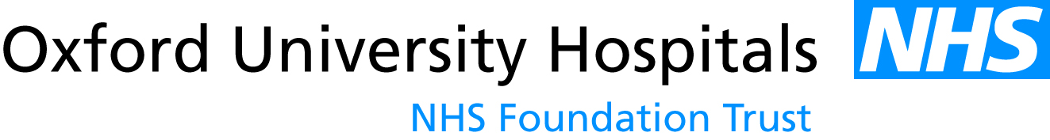

Filming, photography and publicity

PATIENT CONSENT FORM

Patient name:…………………………………………………………………..
(BLOCK CAPITALS)
Address:…………………………………………………………………………

…………………………………………………………………………………….

Telephone No (inc mobile):………………………………………………………………….

Email:………………………………………………………………….

Date:………………………………………………………….…………………..

I hereby confirm that I give consent for the photographs/filming/videotape images/sound recordings (underline as appropriate) (the ‘material’) to be made of me, as set out below.
I also give consent to be included in the publicity as outlined below.

Publication / Media Company:

Event / Outline of filming/ publicity:………………………………………………..…

……………………………………………………………………………………

……………………………………………………………………………………

I understand that the material will be made public. I consent to the material being shown to the general public in all forms of media including television, radio, all forms of publications, journals, on-line publications/websites and other forms of media, including social media channels, and that this could be distributed anywhere in the world (underline as appropriate).

Once the material has been released, I realise that recovery of the material will not be possible. I understand that no fee is payable to me by the NHS or any other person in respect of the material either now or at any time in the future.

I confirm that the purpose for which the material would be used has been explained to me in terms which I have understood. Refusal to consent will in no way affect my medical care.

To be completed by patient and/or parent/guardian (if patient under 16)

Please tick boxes
I agree with above statement…………………………………….
Signature (patient or parent/guardian)

OUH Media and Communications Unit, John Radcliffe Hospital, Oxford, OX3 9DU. Tel: 01865 231471

