OxKen: DPhil in inflammatory and musculoskeletal disease

  - 2024 Intake Project Book
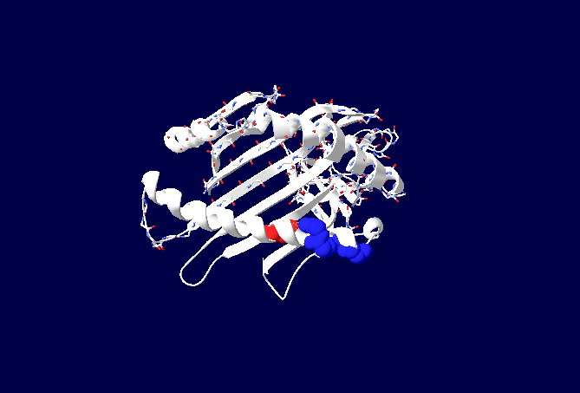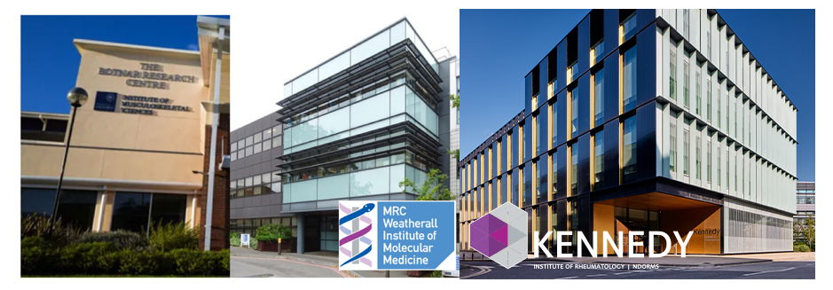
OxKen: DPhil in inflammatory and musculoskeletal disease
2024 Intake Booklet

Introduction

The Kennedy Trust for Rheumatology Research-funded OxKen programme will fully fund 4 intercalating medical students each year undertake DPhils in the Medical Sciences Division in the fields of musculoskeletal disease, inflammation and immunology.

This booklet provides an overview for prospective students looking to study for a DPhil in Inflammation, Immunology and Musculoskeletal Sciences at Oxford University, starting in 2024. Applications are welcomed from current Oxford medical students intercalating after year 3 or year 4 of the standard entry A100 course, or after year 2 of the graduate entry A101 course. The cohort will start on 1 July (or 1 August for first year clinical students) 2024. Applicants from medical students at other UK Universities at the same stage may be considered with the approval of the student’s director of clinical studies.

The Programme provides research based doctoral training for researchers from clinical and biological backgrounds. clinical training. In the programme students will receive a world-leading research training experience that integrates an education initiative spanning patient care, and research impact; on- and post-programme mentorship; and a specialised, fundamental, subject-specific training tailored to individual research needs. Students participating in the scheme will be offered:
• a choice of interdisciplinary cutting-edge research projects.
• the ability to gain a working in-depth knowledge of the fundamentals of inflammatory and musculoskeletal diseases and patient care through advanced level seminars.
• a world-renowned research environment that encourages the student’s originality and creativity in their research.
• opportunities to develop skills in making and testing hypotheses, in developing new theories, and in planning and conducting experiments.
• an environment in which to develop skills in written work, oral presentation and publishing the results of their research in high-profile scientific journals, through constructive feedback of written work and oral presentations.

At the end of their DPhil course, students should:
• have a thorough knowledge of the basic principles of research into inflammatory disorders including the relevant literature and a comprehensive understanding of scientific methods and techniques applicable to their research.
• be able to demonstrate originality in the application of knowledge, together with a practical understanding of how research and enquiry are used to create and interpret knowledge in their field.
• have developed the ability to critically evaluate current research and research techniques and methodologies.
• be able to act autonomously in the planning and implementation of research.
• have the grounding for an influential researcher of inflammatory diseases in the future.

Research Themes
Our research themes relating to musculoskeletal disease are as follows:
- Basic mechanisms of inflammation
- Inflammatory and rheumatic disease
- Patient-reported outcomes and, pain
- Clinical trials and in vivo studies
- Epidemiology, computational and data science
- Tissue engineering and remodelling

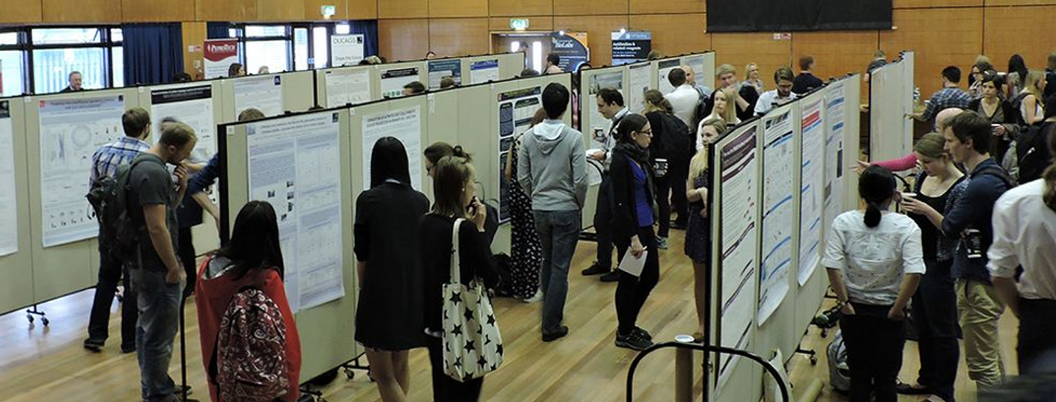

OxKEN Research Themes
2. Inflammatory and rheumatic disease
6. Tissue engineering and remodelling
5. Epidemiology, computation & data science
Brain
Renal
Osteo-arthritis
4. Clinical trials and in vivo studies
Nanchahal (KIR), Dakin (Botnar), Snelling (Botnar), Itoh (KIR), Wann (KIR), Hulley (Botnar), Stride (Botnar)
Prieto-Alhambra (Botnar), Silman (Botnar), Price (Botnar), Glyn-Jones (Botnar), Furniss (Botnar)
Coates (Botnar), Taylor (Botnar), Fullerton, Richards (Botnar, OXCT)
Alsaleh (Botnar)
Buckley (KIRG
Williams (KIR)
Klenerman (TGU)
Uhlig (TGU)
Ogg (WIMM)
Samson (KIR)
Hallou (KIR)

Luqmani (Botnar)
Monaco (KIR)
Casadei (RDM)
Fugger (WIMM)
Pugh (TDI)
O’Callaghan (CCMP)
Vincent (KIR)
Watt (KIR)
1. Basic mechanisms of inflammation
Alsaleh (Botnar), Friedrich (KIR), Dustin (KIR), Udalova (KIR), Midwood (KIR), Powrie (KIR), Rehwinkel (WIMM), Drakesmith (WIMM), Dushek (SWDSP), Greaves (SWDSP), Cornall (CCMP), Coles (KIR), Fullerton (Botnar)
Gut
Skin
Musculo-skeletal
Cardio-vascular
Lung
Ho (WIMM)
3. Patient-reported outcomes and pain
Coates (Botnar)
Abbreviations used: KIR: Kennedy Institute of Rheumatology. WIMM: Weatherall Institute of Molecular Medicine. SWDSP: Sir William Dunn School of Pathology. TGU: Translational Gastroenterology Unit. NDCN: Nuffield Department of Clinical Neurosciences. CCMP: Centre for Cellular and Molecular Physiology. RDM: Radcliffe Department of Medicine. TDI: Target Discovery Institute. OXCT: Oxford Centre for Clinical Therapeutics

Selection Criteria & Eligibility

Due to University requirements this program is only available to current medical students intercalating after year 3 or year 4 of the standard entry A100 course, and after year 2 of the graduate entry A101 course. There are two tracks for training as clinician scientists shown below.
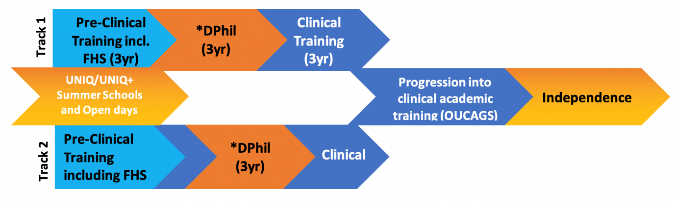
Application Track 1 – Medical Undergraduates current 3rd year preclinical (to start 01 Aug 2024)
Application Track 2 – 1st year clinical students (to start 08 Jul 2024).

All applicants will be judged on the following:
• commitment and passion to a career in translational research in musculoskeletal /inflammatory disease
• evidence of motivation for and understanding of the proposed area of study
• commitment to the subject, beyond the requirements of the degree course
• preliminary knowledge of relevant research techniques
• capacity for sustained and intense work
• reasoning ability and academic curiosity.
Selection criteria will also include the project, the environment and relevance to the KTRR’s mission statement.

Funding
All offered places are fully funded at the home rate. This includes salary/stipend (currently £21,586 PA), University and College fees, and a research consumables budget of £10,000 p.a. Top up fees for one overseas student may be available on a competitive basis. Also, on a competitive basis, we will pay clinical fees for one year for up to two students in track 1 if they do not qualify for funding due to ELQ.

How to Apply
Prospective students should apply with a prioritised list of three projects selected from this booklet by 12:00 midday UK time on: Friday 1st December 2023.

It is strongly suggested that students contact supervisors of projects they are interested in applying for prior to application.

We will also accept student-generated projects in the fields of inflammation and musculoskeletal diseases - although you will need to find projects supervisors.

Applications are invited from 31 Oct 2023 to 1 Dec 2023 (12.00). Please apply through MSD DTC (DPhil in inflammatory and musculoskeletal disease https://www.ox.ac.uk/admissions/graduate/courses/dphil-inflammatory-and-musculoskeletal-disease). Colleges currently accepting OxKen students are listed at the end of this booklet.

Shortlisted students to interview (on Teams) on Tuesday 23 January 2024. Students are welcome to jointly apply for the OxCat and OxKen training programs which will be interviewed together. If successful, students will be allocated a project on the basis of their ranking during the review process.

Projects at a Glance

Project ID | Title | Supervisor(s) | Themes
#OxKEN-2024/1 | Influence of Modifiable factors in PsA contributing to treat to target success (the IMPACT study) | Supervisor 1: Laura Coates  Co-Supervisor/s: Emma Dures, Marie Falahee, Jorien Veldwijk | 4, 3
#OxKEN-2024/2 | Elucidating T cell phenotype and function in frozen shoulder | Supervisor 1: Prof Stephanie G Dakin, Co-Supervisor/s: Prof Christopher Buckley, Prof Mark Coles, Prof Paul Klenerman | 1, 2
#OxKEN-2024/3 | Understanding and exploiting antigen discrimination by T cells | Supervisor 1: Omer Dushek  Co-Supervisor/s: P. Anton van der Merwe | 1
#OxKEN-2024/4 | Gamma-delta intra-epithelial lymphocytes in coeliac disease | Supervisor 1 Paul Klenerman,  Co-Supervisor/s: Michael FitzPatrick, Holm Uhlig | 2
#OxKEN-2024/5 | Investigating the role of neutrophil subsets in vascular inflammation | Supervisor 1: Irina Udalova  Co-Supervisor/s: Professor Raashid Luqmani, Dr Kristina Zec (Versus Arthritis Fellow) | 2, (1)
#OxKEN-2024/6 | Investigating interactions between oxygen-sensing pathways and autoimmunity | Supervisor 1: Fadi Issa  Co-Supervisor/s: Katherine Bull; Joanna Hester; Chris Pugh | 1

#OxKEN-2024/7 | Identifying therapeutic combinations for immune mediated inflammatory disease using computational modelling, artificial intelligence and experimentation | Supervisor 1: Prof. Mark Coles  Co-Supervisor/s: Prof. Eamonn Gaffney, Prof. Christopher Buckley | 5
#OxKEN-2024/8 | Investigation of DDR2 signalling that promotes synovial cell invasion into cartilage in rheumatoid arthritis | Supervisor 1: Prof Yoshifumi Itoh  Co-Supervisor/s: Prof Chris Buckley; Prof Richard Williams | 2 (1)
#OxKEN-2024/9 | Characterizing the ageing phenotype of fibroblast populations in the synovium of RA and OA patients. | Dr Ghada Alsaleh, Prof Tonia Vincent, Professor Christopher Buckley | 2 (1, 6)
#OxKEN-2024/10 | Autoantigen keratin-17 as a key driver of anterior uveitis | Supervisor 1: Prof Christopher Buckley  Co-Supervisor/s: Dr Srilakshmi Sharma, Dr Lakshanie Wickramasinghe | 1
#OxKEN-2024/11 | Spatial exploration of hypoxic signalling and inflammation in chronic hepatitis B. | Supervisor: Jane McKeating and Co-Supervisor: Fadi Issa | 1
#OxKEN-2024/12 | Matrix architecture in the perivascular niche: a master regulator of lymphocyte infiltration in inflammatory disease? | Supervisor 1: Prof Kim Midwood  Co-supervisors: Prof Dame Fiona Powrie, Dr Shirish Dubey, Mr. Jean-Baptiste Richard | 1 (2,6)

#OxKEN-2024/13 | The dark side of hypoferremia: does iron deficiency disable innate immunity in humans? | Supervisor 1: Associate Prof James Fullerton  Co-Supervisor/s: Prof Hal Drakesmith | 1
#OxKEN-2024/14 | Epigenetic targeting of fibroblasts as a novel therapeutic avenue for fibro-stenotic Crohn’s disease | Dr Matthias Friedrich  Co-Supervisor: Professor Simon Travis | 1 (2)
#OxKEN-2024/15 | Interrogating immune-mediated inflammatory disease via cutaneous human immune challenge | Supervisor 1: Assoc Prof James Fullerton  Co-Supervisor/s: Prof Chris Buckley | 1 (2)
#OxKEN-2024/16 | How does SAMHD1 prevent autoinflammatory disease? | Supervisor: Jan Rehwinkel  Co-Supervisor/s: Alexander Clarke | 1
#OxKEN-2024/17 | Updating our knowledge on the epidemiology and aetiology of immune-mediated disease: a network real world data and biobank analysis | Supervisor 1: Prof Daniel Prieto-Alhambra  Co-Supervisor/s: Dr Albert Prats-Uribe, Dr Junqing Xie, Prof Paul Bowness | 5
#OxKEN-2024/18 | Elucidating the Mechanisms of RNA Splicing in the Regulation of Inflammatory Responses | Supervisor 1: Associate Prof Adam Cribbs  Co-Supervisor/s: Associate Prof Sarah Snelling, Prof Dominic Furniss, Dr Mathew Baldwin | 1
#OxKEN-2024/19 | Investigating antigen-specific vaccine responsiveness using lymph node single-cell multi-omics | Supervisor 1: Kat Pollock  Co-Supervisor/s: Calli Dendrou, Mark Coles, Teresa Lambe | 1, 4

OxKen Governance Structure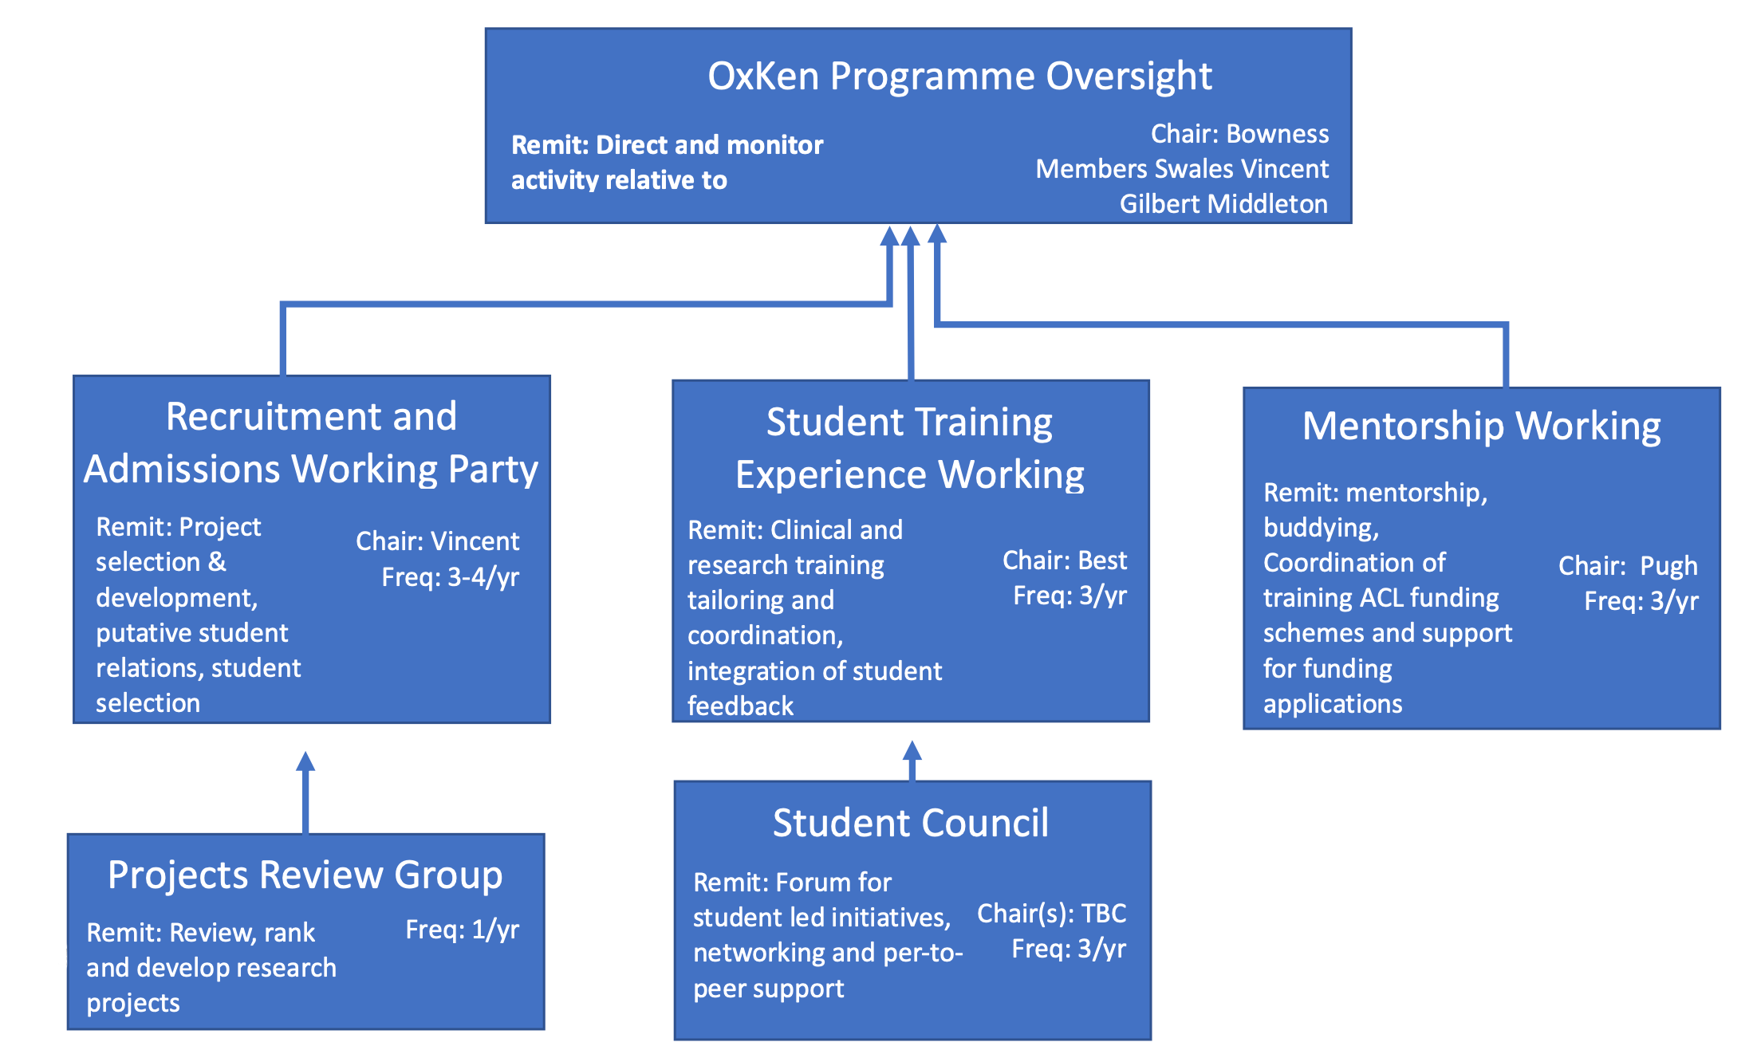

Project Proposals

- Project Title: Influence of Modifiable factors in PsA contributing to treat to target success (the IMPACT study)

Supervisor 1: Laura Coates
Co-Supervisor/s: Emma Dures, Marie Falahee, Jorien Veldwijk

PROJECT OVERVIEW: (500 words maximum)
Around 30% of people with psoriasis will go on to develop a related inflammatory arthritis called psoriatic arthritis. This can cause inflammation in the peripheral joints, tendons, spine and other musculoskeletal tissues and significant impairment of quality of life. A large European consortium of researchers called HIPPOCRATES (https://www.hippocrates-imi.eu/) has been funded to further research into psoriatic arthritis. Within this, Professor Coates is leading a 5-year project examining how to predict and potentially prevent the onset of PsA. This DPhil has been co-designed with members of another large consortium (PREFER) which is examining patient preferences in research.
This DPhil project will establish the acceptability of preventative treatment for PsA amongst people with psoriasis. It will help us to design a future interventional study aiming to prevent the progression to psoriatic arthritis.
Whether people would be happy to join a preventative study is likely to depend on a lot of factors, Training will be provided in qualitative research techniques to lead focus groups of people with psoriasis. This qualitative work will explore the different factors that would influence their choice about enrolling in a preventative study such as:
- Risk of developing arthritis
- Side effects of any medication/intervention
- Whether the medication also improves psoriasis
- What previous treatments people have received for psoriasis
Additional work with patients will explore individual and socio-economic barriers and enablers for people to enrol in a future study and the outcomes important to patients that should be included in a preventative study.
Following this work, with expertise from Dr Falahee and Dr Veldwijk, you will co-design a discrete choice experiment to measure patient’s preferences for preventative therapy. This will explore patient preferences for the attributes of preventative treatments and calculate the minimum benefit levels that patients require given different levels of side effects. This work will build on a threshold technique study that is currently being undertaken looking at these factors. For example, the current study asks:
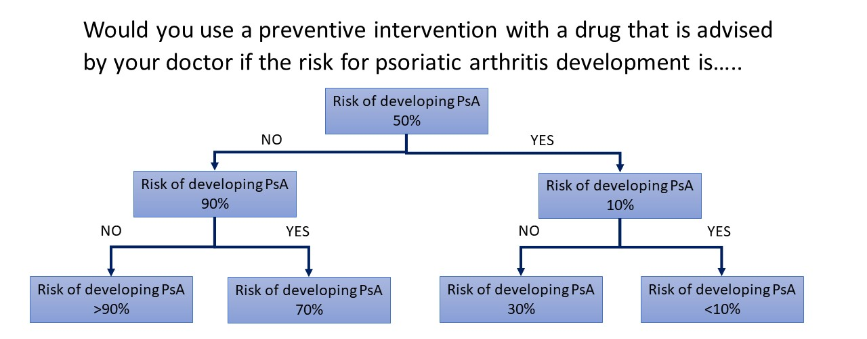
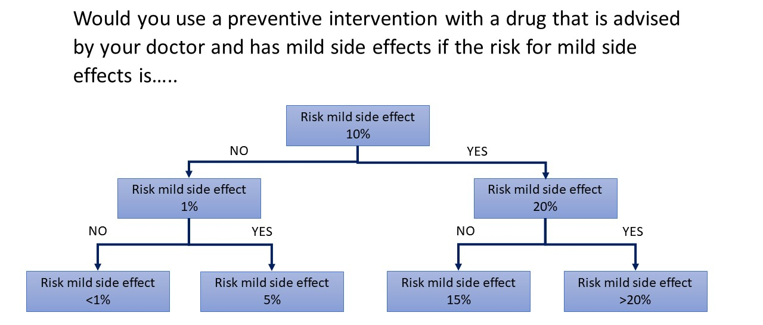
In the discrete choice experiment we will build on these thresholds and give participants a choice between two different theoretical treatments to see which they would decide. They will then be given two different treatment options, each with different side effects and doses. People will also have an option to ‘opt out’ if they would not like to take either treatment.
For example:
“You have recently developed some pain in your joints. Tests have shown that your risk of developing psoriatic arthritis in the next 2 years is 50%. Your doctor has asked you to consider taking a treatment to reduce that risk for one year. Which of these treatments would you pick?”.
 | Drug A | Drug B | No Drug
Risk of developing PsA | 10% | 30% | 50%
Mode of administration | Injection | Oral | -
Treatment frequency | Weekly | Daily
Risk of mild side effects | 5% | 5% | -
Risk of serious side effects | 3% | 1% | -
I would choose

This work will contribute directly to the design of a future trial aiming to test medications aiming to prevent the evolution from psoriasis to psoriatic arthritis. You will be a key member of the international HIPPOCRATES consortium supporting international networking opportunities.

KEYWORDS (5 WORDS): qualitative, patient preferences, psoriatic disease, clinical, priorities

TRAINING OPPORTUNITIES:
This project represents an excellent opportunity for a keen scientist to develop skills in qualitative and patient-focused research. Training will be provided in
- qualitative research and nominal group techniques
- discrete choice experiments
- biostatistics
- patient involvement in research
The supervisors have significant experience in DPhil supervision and are world-leaders in different elements of this proposal. The study will have strong links to two large IMI-funded European research consortia (HIPPOCRATES - https://www.hippocrates-imi.eu/ and PREFER - https://www.imi-prefer.eu/) providing excellent networking with other researchers across Europe.

KEY PUBLICATIONS (5 maximum):
- Coates LC, Moverley AR, McParland L, Brown S, Navarro-Coy N, O'Dwyer JL, Meads DM, Emery P, Conaghan PG, Helliwell PS. Effect of tight control of inflammation in early psoriatic arthritis (TICOPA): a UK multicentre, open-label, randomised controlled trial. Lancet. 2015 Dec 19;386(10012):2489-98.
- Tucker L, Allen A, Chandler D, Ciurtin C, Dick A, Foulkes A, Gullick N, Helliwell P, Jadon D, Jones G, Kyle S, Madhok V, McHugh N, Parkinson A, Raine T, Siebert S, Smith C, Tillett W, Coates LC. The 2022 British Society for Rheumatology guideline for the treatment of psoriatic arthritis with biologic and targeted synthetic DMARDs. Rheumatology (Oxford). 2022 Aug 30;61(9):e255-e266.
- Simons G, Schölin Bywall K, Englbrecht M, Johansson EC, DiSantostefano RL, Radawski C, Veldwijk J, Raza K, Falahee M. Exploring preferences of at-risk individuals for preventive treatments for rheumatoid arthritis. Scand J Rheumatol. 2022 Sep 30:1-11. doi: 10.1080/03009742.2022.2116805. Online ahead of print. PMID: 36178461
- Simons G, Veldwijk J, Disantostefano RL, Englbrecht M, Radawski C, Bywall KS, Valor Méndez L, Hauber B, Raza K, Falahee M. Preferences for preventive treatments for rheumatoid arthritis: discrete choice survey in the UK, Germany and Romania. Rheumatology (Oxford). 2022 Sep 7:keac397. doi: 10.1093/rheumatology/keac397. Online ahead of print.PMID: 36068022
- Dures E, Hewlett S, Lord J, Bowen C, McHugh N; PROMPT Study Group, Tillett W. Important Treatment Outcomes for Patients with Psoriatic Arthritis: A Multisite Qualitative Study. Patient. 2017 Aug;10(4):455-462. doi: 10.1007/s40271-017-0221-4.

CONTACT INFORMATION OF ALL SUPERVISORS:
Email – laura.coates@ndorms.ox.ac.uk
Email – emma2.dures@uwe.ac.uk
Email – m.falahee@bham.ac.uk
Email – veldwijk@eshpm.eur.nl

- Project Title: Elucidating T cell phenotype and function in frozen shoulder

Supervisor 1: Prof Stephanie G Dakin, Co-Supervisor/s: Prof Christopher Buckley, Prof Mark Coles, Prof Paul Klenerman
PROJECT OVERVIEW: Frozen shoulder is a disabling condition affecting 10% of the working population. Disease causes significant pain and immobility of the shoulder joint, reducing life quality of affected patients. Frozen Shoulder is an inflammatory fibrotic disease localised to the shoulder joint capsule. Curiously the disease is self-limiting, as symptoms almost always resolve, albeit over 2-3 years. Frozen shoulder is therefore a unique example of a chronic inflammatory fibrotic disease that resolves and could inform the precise biological cues that govern whether fibrosis persists or resolves. The cellular basis underpinning how inflammatory fibrosis resolves in frozen shoulder is not fully elucidated, however we have identified a mechanism where crosstalk between MerTK+ macrophages and matrix-associated fibroblasts promotes remodelling of the extracellular matrix as one putative mechanism for fibrosis resolution in the shoulder capsule Ng et al, under review). However, the potential contribution of T cells to fibrosis resolution in frozen shoulder remains understudied. Improved understanding the cellular mechanisms underpinning fibrosis resolution will 1) identify new treatments to accelerate resolution of frozen shoulder and 2) inform the biological cues to push persistent inflammatory fibrotic diseases beyond the joint towards a resolving pathway.
In the absence of animal models that accurately recapitulate human disease, we set up the ICECAP clinical study, enabling us to collect well-phenotyped shoulder capsule tissues from patients undergoing surgery for frozen shoulder. We also collect comparator capsular tissues from patients undergoing shoulder stabilisation or arthroplasty procedures. Our scRNAseq data identify that the human shoulder capsule is comprised of distinct tissue-resident stromal cell subsets. We have identified a unique subset of CD3+CD8+CD69+ T cells which appear to be resident in the capsule. These cells also highly express GRANZYME K, GRANULYSIN, IL7R, CXCR4 and KLRB1 (Figure 1). We confirmed expression of these proteins in sections of frozen shoulder patient tissues using ChipCytometry (Figure 2). These T cells exhibit a profile akin to the SCT5 subset identified by Zhang et al. in synovial tissues from patients with rheumatoid arthritis (Zhang et al 2019). This preliminary data suggests that T cells in frozen shoulder may be enriched for cytotoxicity. However, their precise phenotype(s), biological function(s) and how these cells might change in frozen shoulder remain unknown. Pereira et al. identified that Sestrins can induce the re-programming of non-proliferative senescent-like CD8+ T cells, enabling them to acquire broad-spectrum, innate-like killing activity. We therefore hypothesise that T cells in the shoulder capsule are implicated in killing senescent capsular fibroblasts, contributing to resolution processes during frozen shoulder.
The over-arching aim of this project is to elucidate the biological role of T cells in the resolution of frozen shoulder. The specific objectives to address this aim are to:
- Expand the scRNAseq dataset to identify transcriptomic T cell signature(s) in capsular tissues collected from non-diseased comparator and frozen shoulder patient tissues.
- Confirm T cell protein signatures in sections of capsular tissues from comparator and frozen shoulder patients
- Use organoid cultures comprised of patient-derived cells to understand how T cells interact with capsular stromal cells to resolve inflammatory fibrosis in frozen shoulder
- Bioinformatically compare the profiles of capsular T cells in resolving frozen shoulder with T cells in non-resolving fibrotic diseases
In addition to discovering new therapeutic strategies for frozen shoulder, this work will also provide novel insights into the cellular mechanisms of intractable soft tissue inflammatory and fibrotic diseases affecting the lung, liver, kidney and skin which ultimately contribute to 45% of all-cause mortality³, leading towards potential new treatment paradigms.

Figure 1. Cell types comprising the resolving inflammatory fibrotic niche during frozen shoulder.

Figure 1. Cell types comprising the resolving inflammatory fibrotic niche during frozen shoulder. (A) Representative images showing Haematoxylin & Eosin staining of sections of comparator and frozen shoulder patient tissues. Distinct lining and sub-lining regions of the capsule are identified, frozen shoulder tissue sections show increased cellularity and vascularity relative to comparator tissues. Nuclear counterstain is violet, scale bar=50μm. (B-L) scRNA-seq analysis of adult shoulder capsule from tissue biopsy samples collected from comparator (n=6) and frozen shoulder (n=4) patients. (B) UMAP shows the major cell types identified (C) The boxplots show the relative frequencies of the cell types in comparator and frozen shoulder patient tissues highlighting credible differences in the proportion of fibroblasts between these sample types (indicated by *). (D) The 4 identified lymphoid clusters. (E) Violin plots of selected lymphoid cluster marker genes. (F) Relative frequencies of lymphoid clusters in comparator and frozen shoulder patient tissues. (G) The 4 myeloid clusters identified (resolution=0.2). (H) Selected myeloid cluster marker genes. (I) Relative frequencies of myeloid clusters in comparator and frozen shoulder patient tissues. (J) The 6 identified fibroblast clusters (resolution=0.3). (K) Selected fibroblast cluster marker genes. (L) The relative frequencies of the fibroblast clusters in comparator and frozen shoulder patient tissues. The credibility of differences in composition between the frozen shoulder and comparator samples was determined for each cluster (C), (F), (I) and (L) with scCODA(72) (10% FDR). Violin plots in (E), (H), (K) show log-normalized expression values of selected cluster marker genes. Only significant cluster marker genes are shown (Wilcoxon tests, BH adjusted P-values<0.05).
Figure 2. Spatial topography of the resolving fibrotic niche
Figure 2. Spatial topography of the resolving fibrotic niche. Graph shows quantitative analysis of immunostaining for CD3 in comparator (C) and frozen shoulder (FS) patient tissue sections. Panel shows representative ChipCytometry images of T cells in sections of frozen shoulder patient tissues, T cells reside adjacent to vascular endothelium (CD31+). Panels show staining combinations for CD4+ T cells (CD127+), CD8+ T cells (CD161+ GZMK+) and NK cells (CD56+ GZMB+), nuclei counterstained cyan/blue. Cyan represents POPO-1 nuclear counterstain, scale bar=20μm. Statistically significant differences were calculated using pairwise Mann-Whitney U tests. Bars represent median values. *** P<0.001, ** P<0.01.
KEYWORDS (5 WORDS): Musculoskeletal, inflammation, fibrosis, T cells, frozen shoulder

TRAINING OPPORTUNITIES:
This project represents an excellent training opportunity for a young scientist with an interest in biology and bioinformatics. Training will be provided in the following aspects:
- Preparation of capsular patient tissues for NGS and immunostaining
- Analysis of Next Generation Sequencing (NGS) data sets for mechanistic study of T cell gene function
- Bioinformatic modelling of T cell focused ligand-receptor and protein-protein interactions
- Multiplex imaging of stained capsular tissues

KEY PUBLICATIONS (5 maximum):
Ng M, B.R., Gacaferi H, Davidson S, Machado CC, Reekie I, Attar M, Windell D, Kurowska-Stolarska M, MacDonald L, Alivernini S, Garvilles M, Jansen, Bhalla A, Lee A, K, Charlesworth J, Chowdhury R, Klenerman P, Powell K, Hackstein CP, ICECAP study group, Furniss D, Rees J, Gilroy D, Coles M, Carr AJ, Sansom S, Buckley CD, Dakin SG. Primed to resolve: A single cell atlas of the shoulder capsule reveals a cellular basis for resolving inflammatory fibrosis. https://biorxiv.org/cgi/content/short/2023.01.16.522218v1 (2023).
Croft AP, Campos J, Jansen K, Turner JD, Marshall J, Attar M, Savary L, Wehmeyer C, Naylor AJ, Kemble S, Begum J, Dürholz K, Perlman H, Barone F, McGettrick HM, Fearon DT, Wei K, Raychaudhuri S, Korsunsky I, Brenner MB, Coles M, Sansom SN, Filer A, Buckley CD. Distinct fibroblast subsets drive inflammation and damage in arthritis. Nature. 2019 Jun;570(7760):246-251. doi: 10.1038/s41586-019-1263-7. Epub 2019 May 29. PMID: 31142839; PMCID: PMC6690841.
Dakin SG, Coles M, Sherlock JP, Powrie F, Carr AJ, Buckley CD (2018). Pathogenic stromal cells as therapeutic targets in joint inflammation. Nat Rev Rheumatol. Dec;14(12):714-726. doi: 10.1038/s41584-018-0112-7.
Dakin SG, Rangan A, Martinez F, Brealey S, Northgraves M, Kottam L, Cooper C, Buckley CD, Carr AJ. (2019) Tissue inflammation signatures point towards resolution in adhesive capsulitis. Rheumatology (Oxford). 2019 Jan 27. doi: 10.1093/rheumatology/kez007.
Dakin SG, Martinez FO, Yapp C, Wells G, Oppermann U, Dean BJF, Smith RDJ, Wheway K, Watkins B, Roche L, Carr AJ. (2015) Inflammation activation and resolution in human tendon disease. Sci. Transl. Med. 7 (311); 311ra173. doi: 10.1126/scitranslmed.aac4269.
Kendal AR, Layton T, Al-Mossawi H, Appleton L, Dakin SG, Brown R, Loizou C, Rogers M, Sharp R, Carr AJ. Multi-omic single cell analysis resolves novel stromal cell populations in healthy and diseased human tendon. Sci Rep. 2020 Sep3;10(1):13939.

CONTACT INFORMATION OF ALL SUPERVISORS:
Email: stephanie.dakin@ndorms.ox.ac.uk
Email: christopher.buckley@kennedy.ox.ac.uk
Email: markcoles2@kennedy.ox.ac.uk
Email: paul.klenerman@medawar.ox.ac.uk
- Project Title: Understanding and exploiting antigen discrimination by T cells
Supervisor 1: Omer Dushek
Co-Supervisor/s: P. Anton van der Merwe

PROJECT OVERVIEW: (500 words maximum)
T cells use their T-cell receptors (TCRs) to discriminate between lower-affinity self and higher affinity non-self pMHC antigens. Although this process has been widely studied, the underlying mechanisms remain unclear. In particular, it is presently unclear whether co-signalling receptors, including those routinely used for cancer immunotherapy (e.g. PD-1), only impact antigen sensitivity or also impact antigen discrimination. The objective of this project will be to investigate the contribution of various co-signalling receptors to the process of antigen discrimination by T cells and to exploit this information to improve T cell therapies as appropriate. The work will rely on primary human T cells transduced or transfected with a defined TCR to which a panel of pMHC antigens have been identified that bind with a spectrum of affinities (as described in Pettmann et al (2021) eLife). By tampering with individual co-signalling receptors, their impact on antigen sensitivity and discrimination can be quantitatively assessed and rationally exploited for improved T cell based therapies.

KEYWORDS (5 WORDS): T cells, T cell receptor, Antigen discrimination, Co-signalling receptors, T cell therapy

TRAINING OPPORTUNITIES: Primary human T cells (isolation, culture, genetic medication, stimulation), Flow cytometry, Biophysical analysis of TCR/pMHC interactions, Quantitative data analysis, Mathematical modelling

KEY PUBLICATIONS (5 maximum):
Pittman et al (2021) The discriminatory power of the T cell receptor. eLife

Lever et al (2016) Architecture of a minimal signalling pathway explains the T cell response to a 1,000,000-fold variation in antigen affinity and dose. PNAS

Dushek & van der Merwe (2014) An induced rebinding model of T cell antigen discrimination. Current opinions in Immunology

Lever et al (2014) Phenotypic models of T cell activation. Nature Reviews Immunology

CONTACT INFORMATION OF ALL SUPERVISORS:
Email: omer.dushek@path.ox.ac.uk,
anton.vandermerwe@path.ox.ac.uk

- Project Title: Gamma-delta intra-epithelial lymphocytes in coeliac disease

Co-Supervisor/s: Paul Klenerman, Michael FitzPatrick, Holm Uhlig

PROJECT OVERVIEW: (500 words maximum)
Celiac disease is common, increasing in prevalence, and leads to significant morbidity and impaired quality of life for patients. Treatment with a gluten-free diet is burdensome, and there is a significant unmet need for improved diagnostics and therapeutics. Celiac disease also serves as an important model for inflammatory diseases – one where the triggering antigen is clearly defined and the tissue pathology (in disease and resolution) readily available for sampling.
Whilst the role of the gluten-specific CD4+ T cell in the immunopathology of celiac disease is well-studied, the cytotoxic CD8+ and γδ+ T cell populations that accumulate in the mucosa during inflammation are less well understood. In particular, the involvement of γδ T cells, which are hugely increased in number in the epithelium in coeliac disease, remain an enigma. Such cells are likely important in a range of inflammatory diseases but Celiac disease offers an important opportunity to study their role in tissue.
Recent evidence indicates that the T cell receptor (TCR) repertoire of this population is perturbed in coeliac disease, suggestive of an antigen-driven role of γδ T cells in celiac disease. However, these antigens remain unknown, as does the functional role of these intriguing cells in the gut in coeliac disease and elsewhere. This project aims to use novel molecular biology approaches and in vitro assays to answer these questions.
Project aims:
1. Characterize the phenotype and transcriptional state of circulating and intestinal γδ T cell populations in health and celiac disease, using single cell RNA sequencing and flow cytometry as well as new spatial (in situ) methods.
2. Explore the functional responses of T cell clones derived from disease-associated intestinal γδ T cells.
3. Identify putative TCR ligands for disease-associated γδ T cells in vitro using intestinal-derived T cell clones.
Unpublished data from our lab shows that CD8+ and γδ+ T cells in the gut in coeliac disease show skewed TCR repertoires, with candidate disease-associated TCR sequences identified. These populations also differ in their transcriptional profile, suggesting that these two cell types play different roles in the disease process. Funding is secured for sequencing and in vitro work to examine these populations in coeliac disease. In addition, we are analysing a recent, large-scale single-cell RNA sequencing project, which will provide further insights into the interactions between these CD8+ and γδ+ T cells and the epithelial cells in coeliac disease, in particular about potential ligands and antigens. These interactions can be addressed using newer spatial methods including high content staining approaches and spatial transcriptomics.
The lab is based in the Translational Gastroenterology Unit, a world-class translational immunology facility at the JR Hospital. The unit works closely with the clinical department, with opportunities to experience specialist clinics and gastrointestinal endoscopy. The close-knit lab group is a supportive training environment, with extensive experience of training clinician-scientists in DPhil research.

KEYWORDS (5 WORDS): Gastrointestinal immunology, coeliac disease, γδ T cells, Intra-epithelial lymphocytes, transcriptomics

TRAINING OPPORTUNITIES: Human tissue processing, conventional and spectral flow cytometry, FACS sorting, bulk and single-cell RNA sequencing, cell culture, PCR, biostatistics, specialist coeliac disease and gastro-immunology clinics, gastrointestinal endoscopy, research and clinical journal clubs, presentations at national and international meetings.

KEY PUBLICATIONS (5 maximum):
Provine, N.M., Binder, B., FitzPatrick, M.E.B., Schuch, A., Garner, L.C., Williamson, K.D., van Wilgenburg, B., Thimme, R., Klenerman, P., Hofmann, M., 2018. Unique and Common Features of Innate-Like Human Vδ2+ γδT Cells and Mucosal-Associated Invariant T Cells. Front. Immunol. 9, 120–32. doi:10.3389/fimmu.2018.00756
FitzPatrick, M.E.B., Provine, N.M., Garner, L.C., Powell, K., Amini, A., Irwin, S., Ferry, H., Ambrose, T., Friend, P., Vrakas, G., Reddy, S., Soilleux, E., Klenerman, P., Allan, P.J., 2019. Human intestinal tissue-resident memory CD8+ T cells comprise transcriptionally and functionally distinct subsets. Cell Reports (In Press).

CONTACT INFORMATION OF ALL SUPERVISORS:
Michael FitzPatrick Email – michael.fitzpatrick@ndm.ox.ac.uk
Paul Klenerman Email – paul.klenerman@medawar.ox.ac.uk

- Project Title: Investigating the role of neutrophil subsets in vascular inflammation

Supervisor 1: Professor Irina Udalova
Co-Supervisor/s: Professor Raashid Luqmani, Dr Kristina Zec (Versus Arthritis Fellow)

PROJECT OVERVIEW: (500 words maximum)

Vascular pathologies underline devastating diseases ranging from auto-immune vasculitis to the recent COVID-19 pandemic (1). Neutrophils, as the most abundant immune cells, have been reported to intimately interact with the vascular system either via direct cell-cell contact or indirectly through release of inflammatory cytokines or cellular substances. Fully functional mature neutrophils patrol the circulation and tissues to exert anti-microbial activity through several mechanisms including release of cytotoxic products, reactive oxygen species (ROS), neutrophil extracellular traps (NETs) and pore-forming molecules. These activities can cause vascular tissue damage if poorly controlled (2).
Inflammatory responses trigger the release of functionally distinct immature neutrophils into the circulation and tissues in different diseases, including severe COVID-19, where we, and others, identify the presence of neutrophil progenitors (3). Our recent work on auto-immune vasculitis has shown that immature neutrophils can generate dysregulated ROS to cause vascular leakage and damage that may lead to systemic vascular pathology (4). Moreover, we have unravelled novel cell-intrinsic molecular regulators of neutrophil maturation and phenotype and function that may lead to multiple therapeutic strategies tailored to specific conditions (5).
This project will profile core pathways and processes of vascular damage associated with immature neutrophils in Giant Cell Arteritis (GCA)-affected arteries by performing multiplex gene and protein expression analyses using the state-of-the-art spatial biology approaches, such as multi-parameter confocal microscopy and single cell spatial transcriptomics. Specifically the Cell Dive platform which allows for multiplex imaging of a single sample by iterative staining, will be used to expand our analysis of neutrophil- and oxidative tissue damage-associated biomarkers in GCA biopsies. Correlations between molecular signatures of vascular damage associated with immature neutrophils and treatment outcomes will be assessed in a clinically well-defined cohort and validated in an independent replication cohort (Fig overview). To further investigate the cellular and molecular mechanisms of neutrophils function on vasculature, the system of human vascular organoids will be adopted.
The outcome of this study is expected to contribute significantly to development of new targets for therapeutic interventions to prevent detrimental vascular damage that is implicated in many diseases such as auto-immune vasculitis.
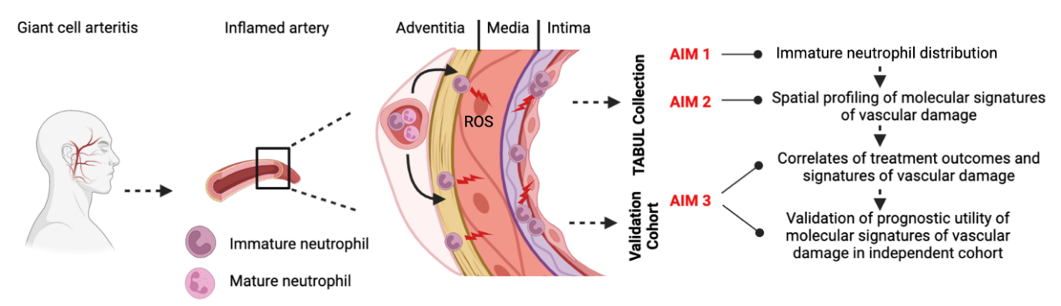

KEYWORDS (5 WORDS): Neutrophils, Vasculitis, Multiplex Imaging, Spatial transcriptomics, Vascular pathologies

TRAINING OPPORTUNITIES:
The Kennedy Institute is a world-renowned research centre and is housed in a brand new state-of-the-art research facility. Training will be provided in techniques in a wide range of immunological tool kits (cell isolation, FACS, ELISA, primary cell culture) and imaging (immunofluorescence on tissue sections) approaches. This rare opportunity to develop vascular organoids will involve stem cell reprogramming and culture. The candidate can benefit from the hands-on experience with these techniques in the Udalova lab, and from access to clinical samples and expertise in their immune analysis in the Luqmani group. Primary human neutrophils and plasma will be prepared from blood samples of patients with well phenotyped forms of vasculitis recruited by Prof Luqmani’s research team. Confocal microscopy will be applied routinely to validate organoid structure and to image neutrophil-vasculature interaction and vascular damages. Multiplex assays such as the Luminex assay will be used for patient plasma profiling to identify key signalling molecules that modulate neutrophil-vasculature interaction. A core curriculum of lectures will be taken in the first term to provide a solid foundation in a broad range of subjects including inflammation, genomics, epigenetics, translational immunology and data analysis. Students will attend weekly seminars within the department and those relevant in the wider University. Students will be expected to present data regularly to the department, the Genomics of Inflammation lab and to attend external conferences to present their research globally. Students will also have the opportunity to work closely with both internal and external collaborators on organoids development.

KEY PUBLICATIONS (5 maximum):
(1) Ponte C, Martins-Martinho J, Luqmani RA. Diagnosis of giant cell arteritis. Rheumatology (Oxford). 2020 May 1;59(Supplement_3):iii5-iii16.
(2) Wang L, Luqmani R, Udalova IA. The role of neutrophils in rheumatic disease-associated vascular inflammation. Nature Review Rheumatology. 2022 Mar;18(3):158-170.
(3) Oxford Covid-19 Immunology Consortium. A blood atlas of COVID-19 defines hallmarks of disease severity and specificity. Cell. 2022 Mar 3;185(5):916-938.e58.
(4) Wang L, Ai Z, Khoyratty T, Zec K, Eames HL, van Grinsven E, Hudak A, Morris S, Ahern D, Monaco C, Eruslanov EB, Luqmani R, Udalova IA. ROS producing immature neutrophils are linked to GCA vascular pathologies. Journal of Clinical Investigations Insight. 2020 Oct 15;5(20):e139163
(5) Khoyratty T*, Ai Z*, Ballesteros I, Mathie S, Eames HL, Martín-Salamanca S, Wang L, Hemmings A, Willemsen N, von Werz V, Zehrer A, Walzog B, van Grinsven E, Hidalgo A, Udalova IA. Distinct transcription factor networks control neutrophil-driven inflammation. Nature Immunology, 2021 Sep;22(9):1093-1106.
CONTACT INFORMATION OF ALL SUPERVISORS:
Professor Irina Udalova Irina.udalova@kennedy.ox.ac.uk
Professor Raashid Luqmani raashid.luqmani@ndorms.ox.ac.uk
Dr Kristina Zec Kristina.zec@kennedy.ox.ac.uk

- Project Title: Investigating interactions between oxygen-sensing pathways and autoimmunity

Supervisor 1: Fadi Issa
Co-Supervisor/s: Katherine Bull; Joanna Hester; Chris Pugh

PROJECT OVERVIEW: (500 words maximum)
Hypoxia complicates most human diseases, and the immune system operates in the resultant environment. Oxygen-homeostatic transcriptional responses are controlled by the hypoxia-inducible factor (HIF) pathways, regulated by the oxygen-sensing HIF hydroxylases (PHD 1-3 and FIH) [1]. We recently discovered that global silencing of PHD2, the major oxygen-sensitive hydroxylase controlling HIF, results in spontaneous development of systemic lupus erythematosus (SLE)-like autoimmunity, associated with impaired regulatory T cell (Treg) function in mice. Importantly this phenotype is reversible when PHD2 is re-expressed [2].
More recently, we tested the immune effects of environmental hypoxia on normal unchallenged adult mice to investigate whether the magnitude of HIF hydroxylase inhibition resulting from physiologically tolerable levels of hypoxia would be sufficient to influence immune status. Systemic hypoxia did produce a small HIF2α-dependent increase in lymph node size, milder than that seen with PHD2 silencing, but associated with an increased incidence of anti nuclear antibody (ANA) positivity (but little evidence of tissue inflammation). Furthermore, we have found that the ability of splenocytes to kill mycobacteria in vitro is enhanced following BCG immunisation combined with hypoxic exposure compared to BCG immunisation alone, mediated at least in part through HIF system effects in Tregs. Importantly, HIF induction via prolyl hydroxylase inhibition is already being used as a treatment for renal anaemia [3] and drugs inhibiting HIF2 dimerisation are showing promising results in the treatment of renal cancer [4].
In this project we will test the hypotheses that 1) HIF pathway induction can potentiate autoimmune responses/phenotypes and 2) that blocking endogenous HIF pathway induction or suppressing HIF2α can enhance immune regulation and ameliorate autoimmune phenotypes. Specifically, we will examine the effects of manipulating the HIF pathway (genetically, by altering oxygen supply, or pharmacologically) in mouse models of autoinflammatory and autoimmune conditions. Initial studies will focus on two models of SLE, TLR7 agonism with Imiquimod, which induces self-reactive antibody production and immune complex mediated renal damage consistent with lupus nephritis and MRL/lpr mice which provide a good polygenic model of multi-system human lupus. Both models can be combined with hypoxic or pharmacological manipulation of the HIF pathway and the Imiquimod model can be applied to mice with genetic HIF pathway manipulations. Sharpin deficient and NOD mice are also available and these experiments are all covered by existing animal licence permissions.
We will then extend this work to investigate the underlying mechanisms linking changes in HIF2α activity to changes in Treg phenotype, but potentially considering effects in other cell types highlighted by the models. Mechanistic studies will combine state of the art approaches including single cell and bulk sequencing, targeted CRISPR and/or small molecule interventions using both animal (perhaps including our humanised mouse models [5]) and in vitro assays (using human or mouse leukocytes). The goal of this latter work being not only to advance knowledge and relate findings to human disease but also to identify intermediary targets that could allow the immune response to be reversibly and precisely tuned without entraining the wide effects of the entire HIF transcriptional pathways.

KEYWORDS (5 WORDS): Hypoxia; autoimmunity; SLE; Treg; HIF

TRAINING OPPORTUNITIES:
Generic skills training would be provided through access to the resources of the University’s Graduate School (see https://www.medsci.ox.ac.uk/study/skillstraining). This covers areas such as experimental design, literature searching, coding, statistics, research presentations and scientific writing.
The project work would involve training in specific skills including, but not restricted to:
- use of animal models;
- informatics relating to single cell sequencing, including RNA velocity;
- signal pathway analysis;
- use of tissue culture models;
and potentially
- Cas9/CRISPR based genetic modification of cells;
- small molecule or RNAi based screens.
Attendance at meetings run by both the Hypoxia Biology Group and Transplantation Research and Immunology Group would ensure a broad grounding in the field of studies. Attendance at seminar series run across the University and meetings held with BMS would add diversity, exposure to a commercial mind-set and exposure to other methodologies.
In addition, the recipient of the Fellowship would receive support from the Oxford University Clinical Academic Graduate School which Chris Pugh directs. This would help with career development and acquisition of skills necessary to progress a clinical academic career, including advice about future grant applications and access to Clinical Lectureships.

KEY PUBLICATIONS (5 maximum):
1. Pugh, C. W. & Ratcliffe, P. J. Exp Cell Res 356(2):116-121 (2017).
2. Yamamoto et al. J Clin Invest 130, 3640-3656 (2019).
3. Chen et al. N Engl J Med 381(11):1011-1022(2019).
4. Courtney et al. J Clin Oncol 36, 867-874 (2018).
5. Adigbli et al. doi: 10.1097/TP.0000000000003177 Transplantation. (2020).

CONTACT INFORMATION OF ALL SUPERVISORS:
Email: Fadi.issa@nds.ox.ac.uk; bullk@well.ox.ac.uk; Joanna.hester@nds.ox.ac.uk; chris.pugh@ndm.ox.ac.uk.

- Project Title: Identifying therapeutic combinations for immune mediated inflammatory disease using computational modelling, artificial intelligence and experimentation

Supervisor 1: Prof. Mark Coles
Co-Supervisor/s: Prof. Eamonn Gaffney, Prof. Christopher Buckley

PROJECT OVERVIEW: (500 words maximum)
Background: Advances in gene sequencing and imaging technologies are transforming how scientists undertake research in rheumatoid arthritis (RA), permitting human data driven therapy development. Using blood and tissue biopsies, we have been developing gene expression maps in joint pathology. Although these datasets have provided key insights into disease, they lack temporal and spatial information limiting their impact on therapeutic discovery and development. Thus, the challenge is to develop and apply new technologies that can provide new insights into RA and identify a cure.

Project Objectives: Using a combination of data analytics, computer simulations and experimental validation to identify disease mechanisms and use artificial intelligence to determine if combinations of existing therapeutics developed to treat cancer or other autoimmune diseases could be a CURE for RA.

Approach: In this project the student will develop and utilise multi-scale computational models, to simulate cellular and molecular interactions in time and space; and apply machine learning-based approaches to identify optimal therapeutic intervention strategies. In this research program we will utilise primary human RA datasets to build computer models focusing on two key disease mechanisms, joint inflammation and cartilage and bone destruction. Using the power of high performance computing, millions of computer simulations can be run, and artificial intelligence applied to identify novel intervention strategies. This will involve screening existing therapeutics that could potentially be repurposed to treat RA. The outputs from these simulations will be validated using human cell culture and in animal models. Because all computer models will be designed using primary human datasets, the translation of predictions to human clinical medicine will be de-risked. This novel approach has the potential to significantly change how therapies for rheumatoid arthritis are identified.

Specific Project Aims
1: Develop a multi-scale temporal and spatial model of macrophage – sublining layer fibroblast (Thy1+) function in human synovium, built on single cell RNAseq, cytometry and immunohistochemistry datasets from early and chronic RA permitting simulation of receptor-ligand interactions and signaling processes in the formation, maintenance and potential resolution of the inflammatory pathology.

2: Generate a computational simulation of lining layer fibroblast (Thy1-PRG4+) migration and invasion of bone and cartilage to identify key regulators of fibroblast directed migration and destructive potential that can be selectively targeted.

Thus the aim of this DPhil project will be to use a combination of modelling, machine learning and experimental validation to identify potential therapeutic targeting strategies for human inflammatory disease.

KEYWORDS (5 WORDS): Computational modelling, systems biology

TRAINING OPPORTUNITIES: The student will be based in the Kennedy Institute of Rheumatology taking advantage of data from world leading technologies in the institute including confocal microscopy, high dimensional Cell Dive imaging and 3D light sheet microscopy. obtain training in key cutting-edge technologies including: 3D light sheet and multi-plex high dimensional imaging; Spatial genomics and big data analysis. They will have access to BMRC computing cluster and appropriate systems biology training and learning computational/mathematical skills including use of Matlab or higher level programming languages.

KEY PUBLICATIONS (5 maximum):
Cosgrove J, Novkovic M, Albrecht S, Pikor NB, Zhou Z , Onder L, Mörbe U, Cupovic J, Miller H, Alden K, Thuery A, O’Toole P, Pinter R, Jarrett S, Taylor E, Venetz D, Heller M, Uguccioni M, Legler DF, Lacey CJ, Coatesworth A, Polak WG, Cupedo T, Manoury B, Thelen M, Stein JV, Wolf M, Leake MC, Timmis J, Ludewig B, Coles MC, B-cell Zone Reticular Cell Microenvironments Shape CXCL13 Gradient Formation, Nature Communications, 2020, Jul 22;11(1):3677. doi: 10.1038/s41467-020-17135-2.
Croft AP, Campos J, Jansen K, Turner JD, Marshall J, Attar M, Savary L, Perlman H, Barone F, McGettrick HM, Fearon DT, Wei K, Raychaudhuri S, Lorsunsky I, Brenner MB, Coles M, Sansom SN, Filer A, Buckley CD, Pathologically distinct fibroblast subsets drive inflammation and tissue damage in arthritis, Nature. 2019 Jun;570(7760):246-251. doi: 10.1038/s41586-019-1263-7
Nayar S, Campos J, Smith CG, Iannizzotto V, Gardner DH, Mourcin F, Roulois D, Turner J, Sylvestre M, Asam S, Glaysher B, Bowman SJ, Fearon DT, Filer A, Tarte K, Luther SA, Fisher BA, Buckley CD, Coles MC, Barone F, Immunofibroblasts are pivotal drivers of tertiary lymphoid structure formation and local pathology. Proc Natl Acad Sci U S A. 2019 Jun 18. pii: 201905301. doi: 10.1073/pnas.1905301116.
Brown LV, Gaffney EA, Wagg J, Coles MC. An in silico model of cytotoxic T-lymphocyte activation in the lymph node following short peptide vaccination. J R Soc Interface. 2018 Mar;15(140). pii: 20180041. doi: 10.1098/rsif.2018.0041.
Aschenbrenner D, Quaranta M, Banerjee S, Ilott N, Jansen J, Steere B, Chen YH, Ho S, Cox K, Arancibia-Cárcamo CV, Coles M, Gaffney E, Travis SP, Denson L, Kugathasan S, Schmitz J, Powrie F, Sansom SN, Uhlig HH. Deconvolution of monocyte responses in inflammatory bowel disease reveals an IL-1 cytokine network that regulates IL-23 in genetic and acquired IL-10 resistance, Gut. 2020 Oct 9:gutjnl-2020-321731. doi: 10.1136/gutjnl-2020-321731

CONTACT INFORMATION OF ALL SUPERVISORS:
Email:
mark.coles2@kennedy.ox.ac.uk
eamonn.gaffney@maths.ox.ac.uk
christopher.buckley@kennedy.ox.ac.uk

- Investigation of DDR2 signalling that promotes synovial cell invasion into cartilage in rheumatoid arthritis

Supervisor 1: Yoshifumi Itoh
Co-Supervisor/s: Chris Buckley; Richard Williams

PROJECT OVERVIEW: (500 words maximum)
A hallmark of rheumatoid arthritis (RA) is the destruction of cartilage and bone by inflamed synovial pannus tissue. The primary cell type that erodes cartilage in RA is synovial fibroblasts (RASF), and we have previously identified the crucial cartilage-eroding proteolytic enzyme, membrane-type 1 matrix metalloproteinase (MT1-MMP), which is highly expressed on the cell surface of RASF (Miller et al., 2009). Inhibition of MT1-MMP completely abolished cartilage invasion of RASF, and selective inhibition of MT1-MMP in a mouse model of arthritis also inhibited cartilage degradation (Kaneko et al., 2016).

MT1-MMP is highly expressed in the RASF at the interface between the pannus and cartilage, suggesting that cartilage may stimulate RASF to express MT1-MMP (Miller et al., 2009). We found that a collagen receptor tyrosine kinase, discoidin domain receptor 2 (DDR2), mediates cartilage collagen signal to synovial fibroblasts and upregulates the MT1-MMP gene (Majkowska et al., 2017). Interestingly, intact healthy cartilage does not activate the DDR2 signal, and cartilage needs to be partially damaged to activate DDR2 in an efficient manner. These findings suggest that DDR2 acts as a sensor detecting cartilage damage. In addition to MT1-MMP gene upregulation, DDR2 signalling also plays a role in regulating MT1-MMP function. Pharmacological inhibition of DDR2 inhibited MT1-MMP activity in RASF, although MT1-MMP is still expressed (Majkowska et al., 2017). These data suggest that the role of DDR2 signalling is not only in MT1-MMP gene upregulation but also modulates other gene expressions to activate synovial cells for tissue destruction.

Recently it was reported that DDR2 contributes to the progression of arthritis by upregulating IL-15 and Dkk-1 in the mouse model of arthritis. A lack of DDR2 and pharmacological inhibition of DDR2 abrogates joint damage in the mouse model of arthritis (Mu et al., Arthritis & Rheum, 2020), which supports our hypothesis of a broader role of DDR2 signalling. However, the mechanism of DDR2 signalling to activate synovial fibroblasts needs further understanding, and a systematic approach to unveil the role of DDR2 signalling is required.

This DPhil project aims to reveal the whole picture of DDR2 signalling and its effects that promote synovial cell invasion. To achieve the goal, we have the following four specific aims.

1. Identify the complete set of genes that DDR2 signalling activates in human synovial fibroblasts by RNAseq;
2. Investigate the roles of the identified genes in the synovial invasion;
3. Investigate the mechanism of DDR2 activation by cartilage;
4. Investigate the expression of the identified genes in the human RA and mouse model of arthritis.

Achieving this DPhil project would significantly deepen our understanding of RA disease progression and may identify novel means to prevent cartilage degradation in RA.

KEYWORDS (5 WORDS):
Rheumatoid Arthritis, Cartilage, DDR2, MT1-MMP, invasion
TRAINING OPPORTUNITIES:
The Kennedy Institute is a world-renowned research centre housed in a state-of-the-art research facility. Full training will be provided in a range of cell and molecular biology techniques. A core curriculum of 20 lectures will be taken in the first term of year 1 to provide a solid foundation in musculoskeletal sciences, immunology, and data analysis. Students will attend weekly departmental meetings and will be expected to attend seminars within the department and those relevant in the wider University. Subject-specific training will be received through our group's weekly supervision meetings. Students will also attend external scientific conferences where they will be expected to present the research findings.

KEY PUBLICATIONS (5 maximum):
1. Gifford, V., and Itoh, Y. (2019) MT1-MMP-dependent cell migration: proteolytic and non-proteolytic mechanisms. Biochem Soc Trans, 47 (3), 811-826
2. Itoh, Y. (2018) Discoidin domain receptors: Microenvironment sensors that promote cellular migration and invasion. Cell Adh Migr. 12 (4), 378-385
3. Majkowska I, Shitomi Y, Ito N, Gray NS, Itoh Y (2017) Discoidin Domain Receptor 2 Mediates Collagen-Induced Activation of Membrane-Type 1 Matrix Metalloproteinase in Human Fibroblasts. J Biol Chem, 292(16):6633-6643
4. Kaneko K, Williams RO, Dransfield DT, Nixon AE, Sandison A and Itoh Y (2016) Selective inhibition of membrane-type 1 matrix metalloproteinase abrogates progression of inflammatory arthritis: synergy with TNF blockade. Arthritis Rheum 68 (2), 521-531
5. Miller MC, Manning HB, Jain A, Troeberg L, Dudhia J, Essex D, Sandison A, Seiki M, Nanchahal J, Nagase H, Itoh Y (2009) Membrane type 1 matrix metalloproteinase is a crucial promoter of synovial invasion in human rheumatoid arthritis. Arthritis Rheum 60(3): 686-697

CONTACT INFORMATION OF ALL SUPERVISORS:
Y. Itoh: yoshi.itoh@kennedy.ox.ac.uk
C. Buckley: christopher.buckley@kennedy.ox.ac.uk
R. Williams: richard.williams@kennedy.ox.ac.uk

- Project Title: Characterizing the ageing phenotype of fibroblast populations in the synovium of RA and OA patients.

SUPERVISORS: Dr Ghada Alsaleh, Prof Tonia Vincent, Professor Christopher Buckley.

PROJECT OVERVIEW:
Rheumatoid arthritis (RA) and osteoarthritis (OA) are the most common forms of arthritis in the UK. These conditions have a very high medico-economic cost. Considerable advances in targeted therapy have improved outcomes in RA, yet a notable percentage of affected individuals still experience persistent inflammation and progressive disability, while for OA there is no effective therapy. Recent results demonstrate that resident cells of synovium, known as fibroblast-like synoviocytes (FLS), are not passive bystanders, but actively contribute to the inflammation and degradative processes in RA and OA. Different synovial fibroblast (SF) populations play key roles in mediating inflammation and bone/cartilage destruction. However, little is known about the molecular mechanisms that drive the different fibroblast behaviors observed in RA and OA; specifically, the enrichment of sublining, proinflammatory fibroblasts in RA compared to the enrichment of lining layer pro-destructive fibroblasts in OA. Differences in the cellular makeup of the synovium between RA and OA could be explained by differential ageing phenotype and senescence of SF subsets. Many studies report the negative effect of cellular senescence in SFs and chondrocytes in OA, yet the therapeutic induction of senescence in RA appears to reduce the activation of inflammatory SFs. This project will examine the role of age-related cellular senescence in determining the cellular structure of the synovium. We will use our combined expertise in fibroblast and ageing biology to test the hypothesis that differential senescence in synovial lining layer fibroblast subsets compared to sub-lining subsets underpins the degree of inflammation vs tissue damage between RA and OA.
PROJECT AIMS:
This PhD studentship has three aims:
Aim1: Molecular characterisation of a panel of the ageing hallmark markers in synovial fibroblast lining and sub-lining layer fibroblast subsets in sex-matched patients across ages in OA and RA using different omics approaches.
Aim 2: Establish the anatomical localization of ageing fibroblast subsets in human OA and RA fibroblast synovium compared to inflammatory arthritis (CIA) and destabilisation of the medial meniscus (DMM) synovium using CellDive and RNA scope analysis to measure the ageing hallmark on transcript levels in parallel with the protein levels
Aim 3: Bioinformatic analysis of the relationship between the ageing hallmarks in the lining and sub-lining fibroblasts in human fibroblast subsets compared to subsets analyzed from established mouse models of inflammatory arthritis (CIA) and degenerative arthritis, the destabilization of the medial meniscus (DMM)

KEYWORDS (5 WORDS): Osteoarthritis, autophagy, ageing, Arthritis, Immunology.

TRAINING
The Botnar Research Centre plays host to the University of Oxford's Institute of Musculoskeletal Sciences, which enables and encourages research and education into the causes of musculoskeletal disease and their treatment. Training will be provided in techniques including flow cytometry, histochemistry, confocal microscopy, RNAscope assays, drug screen design and in vitro cell cultures (2D and 3D) of human chondrocytes, fibroblasts, various cell lines as well as using preclinical in vivo models of OA.
A core curriculum of lectures will be taken in the first term to provide a solid foundation in a broad range of subjects including musculoskeletal biology, inflammation, epigenetics, translational immunology, data analysis and the microbiome. Students will also be required to attend regular seminars within the Department and those relevant in the wider University.
Students will be expected to present data regularly in Departmental seminars, Alsaleh’s group and attend external conferences to present their research globally, with limited financial support from the Department.
Students will also have the opportunity to work closely with colleagues in The Centre for Osteoarthritis Pathogenesis Versus Arthritis (OA Centre, https://www.kennedy.ox.ac.uk/oacentre/oacentre), Oxford, DRFZ Institute (https://www.drfz.de/uber-uns/koepfe/prof-dr-max-loehning/), Berlin, TIGEM Institute (https://www.tigem.it/research/faculty/settembre), Naples, and The Buck Institute for ageing research (https://www.buckinstitute.org/lab/campisi-lab/), California.
Students will have access to various courses run by the Medical Sciences Division Skills Training Team and other Departments. All students are required to attend a 2-day Statistical and Experimental Design course at NDORMS (Nuffield Department of Orthopaedics) and run by the IT department (information will be provided once accepted to the programmer).

SUPERVISORS:
Dr Ghada Alsaleh: https://www.ndorms.ox.ac.uk/research/research-groups/alsaleh-group-aging-in-the-musculoskeletal-system.

Prof Tonia Vincent: https://www.kennedy.ox.ac.uk/research/molecular-pathogenesis-of-osteoarthritis.
Professor Christopher Buckley: https://www.ndorms.ox.ac.uk/research/research-groups/stromal-cell-biology.

KEY PUBLICATIONS:

- Croft, A. P. et al. Distinct fibroblast subsets drive inflammation and damage in arthritis. Nature 570, 246-251, doi:10.1038/s41586-019-1263-7 (2019).
- Alsaleh, G. et al. Autophagy in T cells from aged donors is maintained by spermidine and correlates with function and vaccine responses. Elife 9, doi:10.7554/eLife.57950 (2020).
- Zhang, H. et al. Polyamines Control eIF5A Hypusination, TFEB Translation, and Autophagy to Reverse B Cell Senescence. Mol Cell 76, 110-125 e119, doi:10.1016/j.molcel.2019.08.005 (2019).
- Zheng, G. et al. TFEB, a potential therapeutic target for osteoarthritis via autophagy regulation. Cell Death Dis 9, 858, doi:10.1038/s41419-018-0909-y (2018).

CONTACT INFORMATION:
Dr Ghada ALSALEH
Email: ghada.alsaleh@kennedy.ox.ac.uk

- Project Title: Autoantigen keratin-17 as a key driver of anterior uveitis

Supervisor 1: Prof Christopher Buckley
Co-Supervisor/s: Dr Srilakshmi Sharma, Dr Lakshanie Wickramasinghe

PROJECT OVERVIEW: (500 words maximum)
The uvea is the vascular and pigmented layer of the eye, lying between the sclera and the retina. It consists of the iris, ciliary body and choroid. The components of the uveal tract have several supportive functions for vision. Inflammation in the uvea (uveitis) is a leading cause of blindness in people of working age, responsible for between 10% to 20% of blindness in the United States and Europe. Anterior uveitis is the most common form of uveitis, with a prevalence of 2 per 1000 population. It has a strong genetic association with the class I MHC allele HLA-B27 and is characterised by a build-up of leukocytes within the anterior chamber of the eye with symptoms including pain, photophobia and reduction in visual acuity.
In our laboratory, we have generated a single cell atlas of the human uveal tract, and demonstrated that the stromal cells of the uvea, in particular the fibroblasts, display marked heterogeneity between the three uveal sites (Figure 1). Iris fibroblasts express high levels of keratin-17 (KRT17), an intermediate filament protein which is also found in skin adnexa such as hair follicles and in the nail bed. Unlike in the iris, keratin-17 is not expressed in either the ciliary body or choroid fibroblasts (Figure 2A). This finding has been validated by RNA in situ hybridisation in human eye tissue (Figure 2B&C). Work by other groups has demonstrated that keratin-17 is an autoantigen in psoriasis. This is of relevance to anterior uveitis as patients with psoriasis are more likely to develop anterior uveitis and nail bed disease than the general population.
Our group has received ethical approval to sample aqueous humour and blood from patients with uveitis. This allows us to investigate the cellular basis of anterior uveitis in detail. The three aims for this project are:
- Determine whether patients with anterior uveitis have circulating T-lymphocytes which are reactive to keratin-17.
- Determine whether the aqueous humour of patients with anterior uveitis contains T-lymphocytes reactive to keratin-17.
- Characterise the T-lymphocyte subsets of the aqueous inflammatory infiltrate from patients with anterior uveitis.
The techniques that will be used to investigate these three aims including spectral cytometry using the Cytek Aurora and single cell transcriptomic analysis on the 10X Chromium platform. Both techniques will allow for extensive phenotyping of the leukocyte populations within the aqueous inflammatory infiltrate. In addition, in vitro cellular assays will be used to test T-cell reactivity and proliferation in response to antigens, including keratin-17 peptides.
This project is an excellent opportunity for a DPhil student to develop skills in experimental and computational techniques, and to drive a project that will advance our knowledge of the pathogenesis of anterior uveitis, and its connection with psoriasis in an eye-skin-joint axis.

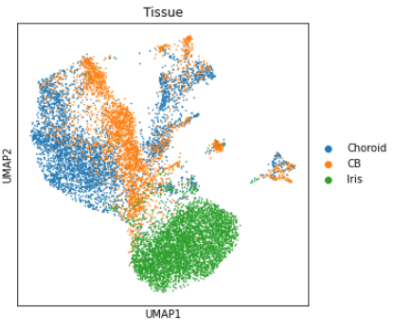
A
B

Figure 1. Single Cell RNA sequencing data demonstrates that fibroblasts of the iris (green) group separately to those of the ciliary body (orange) and choroid (blue) on single cell RNA sequencing.
A: UMAP of fibroblasts, pericytes and endothelial cells from the adult human uvea coloured by tissue of origin.
B: UMAPs of stromal cells coloured by canonical markers of fibroblasts (PDGFRA), pericytes (MCAM) and endothelial cells (VWF).

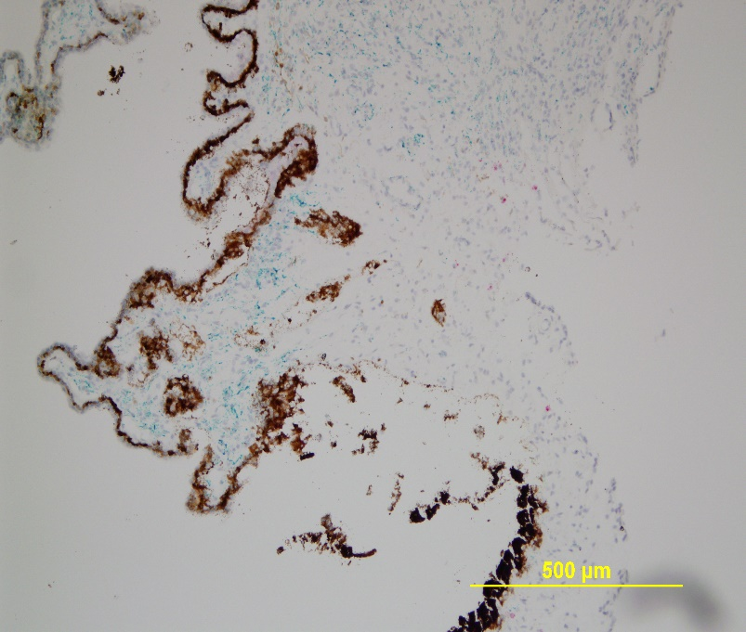
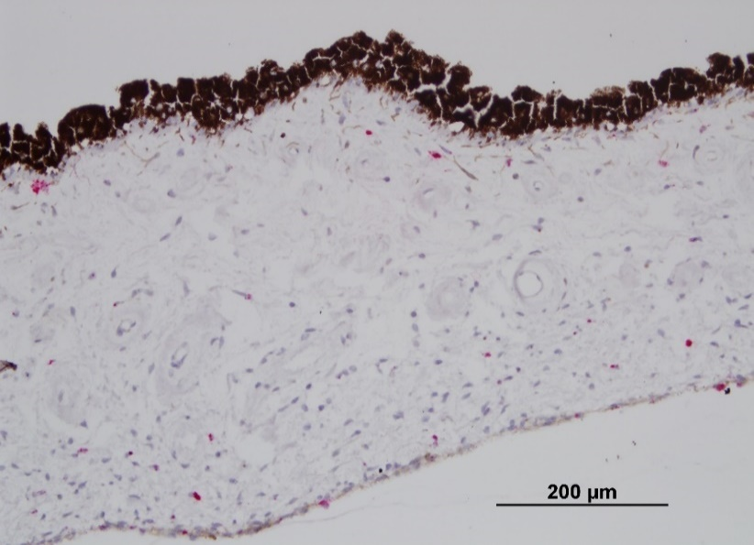
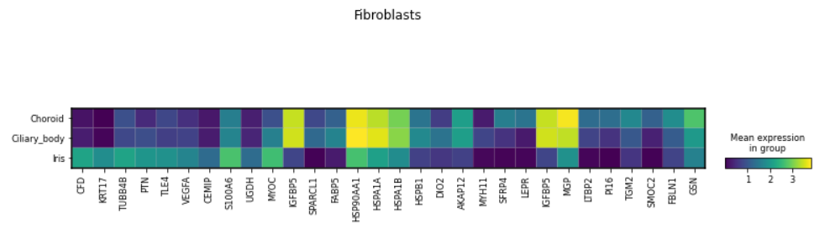
IGFBP5
KRT17
KRT17
B
C
A

Figure 2. Kertain-17 expression is localised to the human iris.
A: Heatmap of top 10 significantly differentially upregulated genes in the fibroblasts of the iris, ciliary body and choroid compared to whole dataset. Keratin -17 marked by red box.
B and C: RNA Scope in situ hybridisation for KRT17 (B) and KRT17 and IGFBP5 (C) on human iris and ciliary body FFPE specimens, showing KRT17 expression specifically in the iris, and IGFBP5 expression specifically in the ciliary body.

KEYWORDS (5 WORDS):
Anterior Uveitis, T-lymphocytes, Keratin-17, Psoriasis, Spondyloarthropathy
TRAINING OPPORTUNITIES:
The student will gain experience of leading a research project where patient samples are taken from bedside-to-bench. It will enable the student to learn a range of state-of-the-art techniques including spectral flow cytometry, bioinformatic single cell RNA sequencing analysis, in vitro culture, and functional cellular assays. The student will be a part of an established team of discovery scientists and clinicians within the Coles-Buckley group based at the Kennedy Institute, who have interest and experience in cross-organ comparison of inflammatory diseases.
The student will present regularly at laboratory and collaborator meetings as well as internal symposia, where they will develop skills in communicating their work to other researchers. They will also be encouraged to submit work to national and international conferences and be supported to write manuscripts for publication. Training is available in systematic literature search methods and the student will produce a literature review in the first part of their DPhil studies, with a view to publication.

KEY PUBLICATIONS (5 maximum):
1. Cunningham, ETE. and Zierhut M, Vision Loss in Uveitis. Ocul Immunol Inflamm, 2021. 29(6): p. 1037-1039.
2. Reekie, I.R., et al., The Cellular Composition of the Uveal Immune Environment. Front Med (Lausanne), 2021. 8: p. 721953.
3. Jin, L. and G. Wang, Keratin 17: a critical player in the pathogenesis of psoriasis. Med Res Rev, 2014. 34(2): p. 438-54.
4. Yunusbaeva, M., et al., Psoriasis patients demonstrate HLA-Cw*06:02 allele dosage-dependent T cell proliferation when treated with hair follicle-derived keratin 17 protein. Sci Rep, 2018. 8(1): p. 6098.
5. Denniston, A.K., et al., Aqueous humor suppression of dendritic cell function helps maintain immune regulation in the eye during human uveitis. Invest Ophthalmol Vis Sci, 2012. 53(2): p. 888-96.

CONTACT INFORMATION OF ALL SUPERVISORS:
Email addresses:
- Christopher.Buckley@kennedy.ox.ac.uk
- Srilakshmi.Sharma@ouh.nhs.uk
- Lakshanie.Wickramasinghe@kennedy.ox.ac.uk

- Project Title: Spatial exploration of hypoxic signalling and inflammation in chronic hepatitis B.

Supervisor 1: Jane McKeating
Co-Supervisor: Fadi Issa

PROJECT OVERVIEW:
Our research group is interested in the cellular basis of early infection events that define virus tropism and how this knowledge translates into new anti-viral strategies. We want to address the fundamental question of ‘how, when and where viruses replicate’ and to understand how they evade immune recognition. Viruses are intracellular pathogens and understanding the host pathways that define susceptibility to infection and disease are essential for the design of new therapies. Viral replication is shaped by the cellular microenvironment and one key factor is local oxygen tension, where hypoxia regulates the transcription of genes involved in metabolism and inflammatory responses.
Hepatitis B virus (HBV) is a global health challenge and major cause of liver disease and cancer. Chronic hepatitis B is an inflammatory disease that reflects a dynamic interaction between the virus and host immune system. The liver is a naturally hypoxic organ and our recent studies identify a role for hypoxia inducible factors (HIFs) to activate HBV transcription. Hypoxia can also suppress anti-viral cellular immunity by recruiting regulatory T-cells (Tregs) and myeloid-derived suppressor cells (MDSCs) to low oxygen areas of the liver, thereby providing an environment for viral persistence. Understanding the pathways that define host susceptibility to viral mediated inflammation is the ‘holy grail’ of this field.
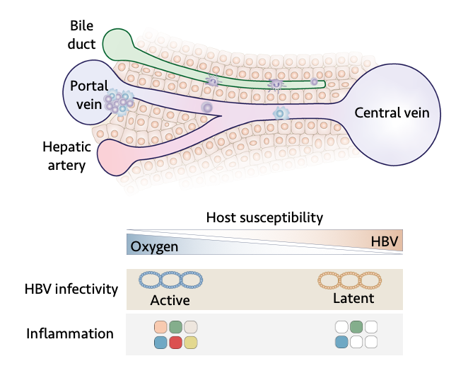
This DPhil will use Digital Spatial transcriptional Profiling (DSP) to identify immune cell populations and infected hepatocytes at the whole transcriptome level in liver biopsies. We will focus on immunosuppressive Tregs and assess whether hypoxic gene signatures impact on cell frequency, location and activation status. Nearest neighbour analysis will examine these cellular interactions at the micro-anatomic level. Staining liver sections for HBV RNAs will enable us to identify immune cells with intracellular viral nucleic acids. For example, liver resident macrophages or Kupffer cells may scavenge HBV and identifying their sub-cellular localisation will uncover new aspects of immune surveillance. Key genes and immune cell types that associate with HBV replication parameters in the tissue will be validated using in vitro viral replication model systems. Pharmacological inhibitors of HIF signalling will define the mechanism underlying the hypoxic control of immune cell activity and virus regulation. The DPhil student will apply these exciting technologies allow us to study virus-host interplay at the single cell level in unprecedented detail. Collectively, this project will test our hypothesis that localised hypoxia regulates the accumulation and function of key effectors such as tissue resident memory T cells and localised suppressor mechanisms, providing new therapeutic insights.
KEYWORDS: Spatial, hepatitis, Inflammation, hypoxia, virus
TRAINING OPPORTUNITIES: The student will join a dynamic and lively team of biologists funded by a prestigious Wellcome Discovery Award that will provide a unique training environment to gain expertise in super resolution imaging techniques to visualize viral RNAs in complex tissues, digital spatial profiling and bio-informatic analysis of inflammatory transcriptomic data sets. Transferable skills include oral presentations at joint lab meetings, critical review of published scientific literature by contributing to journal clubs and scientific writing by reviewing and drafting manuscripts for publication. The student will work in Nuffield Department of Medicine Research Building and Department of Surgical Sciences (John Radcliffe Hospital, Oxford) and will have the opportunity to interface with a network of collaborators in Oxford, UK and internationally to translate their data to the wider biomedical community.

KEY PUBLICATIONS:
Wing PAC et al. Hypoxia inducible factors regulate hepatitis B virus replication by activating the basal core promoter. J Hepatol. 2021 Jul;75(1):64-73. doi: 10.1016/j.jhep.2020.12.034.
Wing PAC et al. Hypoxic and pharmacological activation of HIF inhibits SARS-CoV-2 infection of lung epithelial cells. Cell Rep. 2021 Apr 20;35(3):109020. doi:10.1016/j.celrep.2021.109020.
Wing PAC et al. Hypoxia inducible factors regulate infectious SARS-CoV-2, epithelial damage and respiratory symptoms in a hamster COVID-19 model. PLoS Pathog. 2022 Sep 6;18(9):e1010807. doi: 10.1371/journal.ppat.1010807.
Cross AR et al. Spatial transcriptomocs characterization of COVID-19 pneumonitis identifies immune circuits related to tissue injury. JCI Insights 2022, in press.
Bottomley MJ et al. Dampened Inflammatory Signalling and Myeloid-Derived Suppressor-Like Cell Accumulation Reduces Circulating Monocytic HLA-DR Density and May Associate With Malignancy Risk in Long-Term Renal transplant patients. Front Immunol 2022 Jul 1;13:901273.doi: 10.3389/fimmu
CONTACT INFORMATION OF SUPERVISORS:
Email: janemckeating@ndm.ox.ac.uk and fadi.issa@nds.ox.ac.uk and informal enquiries are welcome.

- Matrix architecture in the perivascular niche: a master regulator of lymphocyte infiltration in inflammatory disease?

Supervisor 1: Prof Kim Midwood
Co-supervisors: Prof Dame Fiona Powrie, Dr Shirish Dubey, Mr. Jean-Baptiste Richard

PROJECT OVERVIEW: (500 words maximum)

Rheumatoid arthritis (RA) is an autoimmune disease of poorly understood aetiology, primarily characterised by inflammation and swelling of the joints, and which can lead to loss of function and disability (1). Under pathological conditions both the architecture and cellular landscape of the synovium, the primary site of RA inflammation, are significantly altered (2,3). The ingress and accumulation of lymphocytic cell subsets is a key feature of the histopathology of inflammatory arthritides and plays a crucial role in the establishment of a tissue-specific chronic inflammatory milieu (4). The primary focus of the Midwood group is on extracellular matrix (ECM) immunology in disease settings. While the ECM was long thought of as simply an inert scaffold in which cells are embedded, it is now evident that it plays key roles in defining tissue properties, cell spatial organisation and functional polarisation. ECM compositional biases are associated with growth, metastatic potential, and treatment refraction in cancer (5), and matrix dysregulation is also emerging as a key driver of inflammatory conditions, including RA (6,7).

Work focusing on elucidating the spatial and temporal dynamics of the poorly characterised ECM of the inflamed arthritic synovium reveals two distinct classes of matrix architecture associated with blood vasculature. This perivascular organization is conserved in different synovial diseases, and matrix composition in this niche significantly correlates with tissue lymphocyte levels in arthritis patient synovial biopsy sections. This project will investigate the hypothesis that the vascular architecture plays a key role in bidirectional lymphocytic trafficking in and out of inflamed tissues.

In this project, the DPhil student will assess whether type I and type II perivascular architecture is specific to the synovium, or a universal feature of blood vessels across human pathology, including inflammatory bowel disease, fibrotic diseases, and tumours. We will characterise the cellular landscape within each type of perivascular niche using multiplexed immunofluorescence to delineate cell lineage, phenotype and activation status, and spatial transcriptomics to uncover transcriptional conversations between niche-specific endothelial-lymphocytic interaction networks. Analysis of T cell migration in vitro using artificial basement membrane constructs to recapitulate type I and II vasculature will provide a tractable model for gene expression and pathway validation and to understand the mechanisms by which matrix composition controls lymphocyte trafficking.

Keywords: ECM, inflammation, arthritis, lymphocyte infiltration, omics

Training opportunities: Spatial transcriptomics and proteomics, multiplexed tissue imaging, bioinformatic analysis of omics data from published and generated datasets, developing expertise in in vivo and in vitro models of inflammation, expert understanding of links between tissue microenvironment and inflammation, presenting and networking in high profile academic settings.

Key publications:
1. Gulati M, Farah Z, Mouyis M. Clinical features of rheumatoid arthritis. Medicine. 2018 Apr 1;46(4):211–5.
2. Zhang F, Wei K, Slowikowski K, Fonseka CY, Rao DA, Kelly S, et al. Defining inflammatory cell states in rheumatoid arthritis joint synovial tissues by integrating single-cell transcriptomics and mass cytometry. Nat Immunol. 2019 Jul;20(7):928–42.
3. Kurowska-Stolarska M, Alivernini S. Synovial tissue macrophages in joint homeostasis, rheumatoid arthritis and disease remission. Nat Rev Rheumatol. 2022 Jul;18(7):384–97.
4. Zhang F, Jonsson AH, Nathan A, Wei K, Millard N, Xiao Q, et al. Cellular deconstruction of inflamed synovium defines diverse inflammatory phenotypes in rheumatoid arthritis. bioRxiv; 2022. p. 2022.02.25.481990.
5. Henke E, Nandigama R, Ergün S. Extracellular Matrix in the Tumor Microenvironment and Its Impact on Cancer Therapy. Frontiers in Molecular Biosciences. 2020;6.
6. Friedrich M, Pohin M, Jackson MA, Korsunsky I, Bullers SJ, Rue-Albrecht K, et al. IL-1-driven stromal–neutrophil interactions define a subset of patients with inflammatory bowel disease that does not respond to therapies. Nat Med. 2021 Nov;27(11):1970–81.
7. Aungier SR, Cartwright AJ, Schwenzer A, Marshall JL, Dyson MR, Slavny P, et al. Targeting early changes in the synovial microenvironment: a new class of immunomodulatory therapy? Ann Rheum Dis. 2019 Feb;78(2):186–91.

Contact information:
Prof Kim Midwood email – kim.midwood@kennedy.ox.ac.uk
Prof Dame Fiona Powrie email - fiona.powrie@kennedy.ox.ac.uk
Dr Shirish Dubey - Shirish.Dubey@ouh.nhs.uk
Jean-Baptiste Richard email – jean-baptiste.richard@new.ox.ac.uk

- The dark side of hypoferremia: does iron deficiency disable innate immunity in humans?

Supervisor 1: Associate Prof James Fullerton
Co-Supervisor/s: Prof Hal Drakesmith

PROJECT OVERVIEW: (500 words maximum)
During infection iron is sequestered from plasma via the regulatory hormone hepcidin. Classically, this is a beneficial ‘nutritional immune’ mechanism that protects against extracellular siderophilic bacterial pathogens. However, it is now recognised there is a ‘dark side’ to hypoferremia. Prolonged reduction in serum iron not only reduces erythropoiesis, causing the anaemia of chronic disease, but additionally impacts on leukocyte function.
Observational studies in individuals with hypoferremia have repeatedly highlighted functional deficits in both the innate and adaptive immune systems with consequent susceptibility to infection and impairment of responses to immunisation. Furthermore, individuals possessing mutations in the TFRC gene that encodes transferrin receptors experience a severe combined immune deficiency, with recurrent infection, neutropenia and hypogammaglobulinaemia.
Recent work in the Drakesmith lab (see Frost et al 2022) has dissected the pivotal role of serum iron in neutrophil production and function. Experimentally induced hypoferremia in mice caused a specific reduction in both baseline and inflammation-induced granulopoesis, highlighting sensitivity to iron availability. Those neutrophils that were released displayed reduced reactive oxygen species generation, impaired phagocytosis of Gram positive and negative organisms, attenuated cytokine release, altered NETosis and reduced bacterial killing: all consistent with clinical susceptibility to infection and immunopathology. This data supports hypoferremia as a key and, most importantly, clinically modifiable modulator of innate immune function.
In this project we seek to translate this work using human experimental challenge paradigms. Self-reported healthy volunteers (18-40) will have their iron status screened for occult iron deficiency (ID) and cohorts of those with confirmed ID (transferrin saturation [TSAT] <10%), borderline ID (TSAT 10-20%) and normal iron status (TSAT >20%) recruited. Ex-vivo functional assays using granulocytes and peripheral blood mononuclear cells (PBMC) obtained from blood will be performed to explore specific neutrophil, monocyte and lymphocyte functional deficits between groups. Recapitulation of observed deficits in those with hypoferremia in vitro via deprivation of iron to effector cells will be evaluated, as will therapeutic rescue with replenishment.
The three groups will subsequently be challenged with intradermal injection (ID) of lipopolysaccharide (LPS, see Buters et al 2022 and Figure) to elicit a transient local inflammatory response in the skin, akin to cellulitis. The clinical response will be quantified via multispectral imaging (erythema, oedema) and laser Doppler (vascular reactivity) prior to formation and aspiration of a blister over the site (via negative pressure, see Figure) at multiple time points (24h, 48h, D7). Flow cytometric and transcriptomic analysis of the cellular component alongside elucidation of the humoral cytokine profile will determine if functional deficits observed in vitro are replicated in vivo. Within subject repetition of the challenge in those with ID post therapeutic replacement will enable incontrovertible proof of the link between iron status and innate immune deficiency.
This novel work is expected to have significant impact, not only on our understanding of how iron mechanistically regulates protection from infection in the common contexts of iron deficiency and inflammatory disease in humans, but on the management of the circa ~1.5 billion individuals worldwide who are ID.
Left Panel (Buters et al 202, DOI: 10.1111/bcp.149992: Timecourse of intradermal (ID) LPS injection. Right Panel (Akbar et al 2013, DOI: 10.1111/cei.12107): Formation and aspiration of aspiration of a suction blister over an ID challenge

KEYWORDS (5 WORDS): Iron; inflammation; experimental medicine; neutrophils; innate immunity

TRAINING OPPORTUNITIES:
The successful student will train in a truly translational environment, being mentored by an experienced supervisory team with complementary interdisciplinary skills in human and mouse immunology, experimental medicine and clinical pharmacology and therapeutics.
Placement in the Oxford Centre for Clinical Therapeutics (OCCT, Fullerton) will afford full exposure to the design, initiation and conduct of early phase clinical trials. In addition, via working alongside exisiting clinical and non-clinical post docs and DPhil students, the accrual of a unique skillset in both the practical conduct of human challenge studies and their interpretation will be facillitated. Studies will principally be conducted in the new NIHR Experimental Medicine Clinical Research Facility (https://www.ndorms.ox.ac.uk/oxford-emcrf) with access to laboratories at the Botnar Research Centre and Kennedy Institute of Rheumatology for sample processing. The student will additionally be expected to participate in and contribute to OCCT meetings and events where the evaluation of new and exisiting medicinal compounds are discussed, shaping their therapeutic development.
Through the MRC Human Immunology Unit (Drakesmith) the student will be trained in standard immunological techniques for evaluating the systemic and localised immune responses, including the functional assessment of innate immune responses (e.g. neutrophil chemotaxis, phagocytosis and reactive burst). To complement these, flow and mass cytometry, imaging, bioinformatics and ‘omics approaches, will be employed to quantify and qualitatively describe the immunological response, linking in vitro and ex vivo observations to those made in vivo.
Oxford graduate training additionally includes core workshops, seminars, career events and online resources to enable the development of intellectual and technical research capabilities, capacity for independent and team-work, and skills to effectively communicate research to the broader scientific community and general public.
We encourage anyone interested in applying to make contact with us.

KEY PUBLICATIONS (5 maximum):
Frost et al, Plasma iron controls neutrophil production and function. Science Advances, 2022. https://doi.org/10.1126/sciadv.abq5384
Bonnadonna et al, Iron regulatory protein (IRP)–mediated iron homeostasis is critical for neutrophil development and differentiation in the bone marrow. Science Advances, 2022. https://doi.org/10.1126/sciadv.abq4469
Buters et al, Intradermal lipopolysaccharide challenge as an acute in vivo inflammatory model in healthy volunteers. Br J of Clinical Pharmacology, 2022 https://doi.org/10.1111/bcp.14999
Frost et al, Hepcidin-Mediated Hypoferremia Disrupts Immune Responses to Vaccination and Infection. Med, 2020. https://doi.org/10.1016/j.medj.2020.10.004
Maini et al, A Comparison of Human Neutrophils Acquired from Four Experimental Models of Inflammation. PLoS One, 2016. https://doi.org/10.1371/journal.pone.0165502

CONTACT INFORMATION OF ALL SUPERVISORS:
Email: james.fullerton@ndorms.ox.ac.uk.
Profile: https://www.ndorms.ox.ac.uk/team/james-fullerton

Email: alexander.drakesmith@ndm.ox.ac.uk.
Profile: https://www.imm.ox.ac.uk/people/alexander-drakesmith

- Project Title: Epigenetic targeting of fibroblasts as a novel therapeutic avenue for fibro-stenotic Crohn’s disease

Supervisor 1: Dr Matthias Friedrich
Co-Supervisor: Professor Simon Travis

PROJECT OVERVIEW: (500 words maximum)
An increasing number of people suffer from Crohn’s disease (CD), not only in industrialised countries, but also in the Middle East, India, East Asia and Latin America. CD causes inflammation that spans all layers of the gastro-intestinal wall. In more than two-thirds of patients, the distal part of the small intestine (ileum) is affected. Up to 80% of these patients require surgery in their lifetime, because fibrosis – the excessive deposition of connective tissue – narrows the intestinal lumen. Rates of postoperative recurrence of fibrosis in CD are high (>80%), significantly reducing patients’ quality of life and making the clinical management of CD challenging and costly. Commonly used medications to control inflammation in CD do not stop or reverse fibrosis, often rendering surgery the only option for intestinal obstruction. We therefore have to research the underlying causes of fibrosis progression, in order to provide better and alternative medical treatment options for patients.
Within this program, we will achieve this by:
- Focusing on the role of connective tissue fibroblasts, the dominant contributor to fibrosis in the tissue, and their interaction with immune and muscle cells;
- Using an animal model that mirrors fibroblast-driven progression of small intestinal fibrosis over time. This model also enables studying the effect on fibrosis progression when disrupting specific functions of fibroblasts;
- Studying the characteristics of pro-fibrotic fibroblasts, and specifically unexplored epigenetic changes that render it pro-fibrotic. In contrast to genetics, the ‘code’ (DNA) of the genome, epigenetics studies an additional layer of DNA modification (‘histone code’) which alters the accessibility of the genome for reading and writing;
- Assessing potential epigenetic modifiers to reverse pro-fibrotic fibroblasts back to normal fibroblasts.
Potential applications and benefits:
The overarching objective of this research is to generate fundamental insights into fibroblast-driven mechanisms of intestinal fibrosis, which can be leveraged for the rational design of anti-fibrotic drugs that are desperately needed. This is the translational interface between science and medicine.
As such, other researchers and clinicians will benefit from the generated insights into fibrosis pathogenesis, advancing our knowledge of this pathology and enabling the development of better advanced therapies. Within the proposed study, we will test the potential of targeting several fibroblast-specific pathways. In particular the epigenetic reversal of pro-fibrotic fibroblasts harbours great potential as a therapy once fibrosis is established. At the same time, the concept of an epigenetically-rewired pathologic fibroblast state is novel and will represent a major conceptual advance to the field. Furthermore, the study of fibrogenesis is pluripotential, since it applies to any organ in the body.
This study will lay the foundation for subsequent rational drug design in collaboration with pharmaceutical industry partners and bench-to-bedside translation initiatives. By doing this, we ensure that we are pursuing the most direct path to provide benefit for the patient in the clinic for this unmet need.

KEYWORDS (5 WORDS): fibrosis, Crohn’s, epigenetic, fibroblast, therapeutic

TRAINING OPPORTUNITIES:
Within this DPhil, you will have the opportunity to apply molecular and cellular in situ patient cohort phenotyping, pre-clinicial in vivo disease models, and in vitro screening and mechanistic assays, to study the role of epigenetics and fibroblasts in Crohn’s disease. This will include cutting-edge techniques such as: spatial transcriptomics (Nanostring GeoMx or 10X Visium) and proteomics (laser dissection mass spec proteomics); RNAseq, ATACseq and ChIPseq; in vivo diseas models (mouse) based on Cre-loxP genetic modification; CRIPSR-Cas9 cellular manipulation; high-throughput therapeutic compound screens.
You will be working in a highly interdisciplinary team consisting of basic researchers, gastroenterologists, GI pathologists and computational biologists across Oxford and Cambridge univiersities, as well as the Cleveland Clinic in the U.S. There will be further opportunities to carry out specific sub-projects through established collaborations with pharmaceutical industry (Bristol Myers Squibb, Pfizer, Janssen, UCB, among others). You will receive clise supervision by both a basic scientist and a clinician – an ideal setting to carry out a DPhil that focusses on bench-to-bedside translation.

KEY PUBLICATIONS (5 maximum):
- Friedrich M.*, Pohin M.*, Jackson M.A.*, Korsunsky I., Bullers S., Rue-Albrecht K., Christoforidou Z., Sathananthan D., Ravindran R., Peres R.S., Sharpe H., Wei K., Watts G.F.M., Mann E.H., Geremia A., Thomas T., Attar M., Oxford IBD Cohort Cohort Investigators, Roche Fibroblast Network Consortium, McCuaig S., Thomas L., Collantes E., Uhlig H.H., Sansom S., Easton A., Raychaudhuri S., Travis S.P., Powrie F.M. IL-1-driven stromal-neutrophil interaction in deep ulcers defines a pathotype of therapy non-responsive inflammatory bowel disease. Nature Medicine 2021; 27:1970. DOI: https://doi.org/10.1038/s41591-021-01520-5
- Friedrich M.*, Pohin M.*, Powrie F. Cytokine Networks in the Pathophysiology of Inflammatory Bowel Disease. Immunity 2019; 50:992. DOI: 10.1016/j.immuni.2019.03.017
- West N *, Hegazy A *, Owens B, Bullers S, Linggi B, Buonocore S, Coccia M, Görtz D, This S, Stockenhuber K, Pott J, Friedrich M, Ryzhakov G, Baribaud F, Brodmerkel C, Cieluch C, Rahman N, Müller-Newen G, Owens R, Kühl A, Maloy K, Plevy S, Keshav S, Travis S, Powrie F. Oncostatin M drives intestinal inflammation and predicts response to tumor necrosis factor–neutralizing therapy in patients with inflammatory bowel disease. Nature Medicine 2017; 23:579. DOI: 10.1038/nm.4307
- Korsunsky I.*, Wei K.*, Pohin M.*, Kim E.Y.*, Barone F.*, Kang J.B., Friedrich M., Turner J., Nayar S., Fisher B.A., Raza K., Marshall J.L., Croft A.P., Sholl L.M., Vivero M., Rosas I.O., Bowman S.J., Coles M., Frei A.P., Lassen K., Filer A., Powrie F., Buckley C.D., Brenner M.B., Raychaudhuri S. Cross-tissue, single-cell stromal atlas identifies shared pathological fibroblast phenotypes in four chronic inflammatory diseases. Med 2022; DOI: 10.1016/j.medj.2022.05.002
- Landerholm K., Reali C, Mortensen N.J., Travis S.P.L., Guy R.J., George B.D. Short- and long-term outcomes of strictureplasty for obstructive Crohn’s disease. Colorectal Disease 2020. DOI: 10.1111/codi.15013

CONTACT INFORMATION OF ALL SUPERVISORS:
Email: matthias.friedrich@ndm.ox.ac.uk
simon.travis@kennedy.ox.ac.uk

- Project Title: Interrogating immune-mediated inflammatory disease via cutaneous human immune challenge

Supervisor 1: Assoc Prof James Fullerton
Co-Supervisor/s: Prof Chris Buckley

PROJECT OVERVIEW: (500 words maximum)
Human immune challenge (HIC), where an exogenous stimulant is employed to transiently induce normally quiescent pathways, cell populations and genes in healthy volunteers (HV), permits unique insights into fundamental biology at high temporal and spatial resolution. Through the elicitation of disease-relevant targets or biomarkers they additionally allow the therapeutic potential of existing and novel drug candidates to be evaluated, rapidly confirming pre-clinical data and gaining early proof-of-mechanism and pharmacology, including at the biophase (target tissue) of interest, prior to entering a patient population. Despite clear scientific and economic advantages over alternate approaches (e.g. animal models) HIC remains under utilised in both discovery biology and drug development programmes largely through insufficient characterization, heterogeneity in methodology and a historical failure to exploit the access to mechanism-related end-points they afford.
Several cutaneous HIC paradigms exist that induce a self-resolving inflammatory reaction via chemical (e.g. cantharidin), physical (e.g. UV-light) or pathogen-derived (e.g. endotoxin) stimuli. The subsequent immunological response can then be quantified clinically over time and the humoral and cellular elements accessed via blistering or skin biopsy. These approaches can be used not only to ‘model’ inflammatory dermatological conditions such as psoriasis or atopic dermatitis, but also to employ the skin as an exemplar tissue bed: gaining insight into pathological processes that occur in others (e.g. the lung or kidney). The problem is that we do not currently have a clear idea which stimuli best induce pathways relevant to different immune-mediated inflammatory diseases (IMID), what dose of stimuli to employ and both when and how to sample the skin to derive the greatest biological insight and optimally inform drug development decisions.
This experimental medicine project seeks to directly address this gap, comparing the response to alternate cutaneous HIC stimuli both within and between HV, hypothesizing that they will selectively elicit immunological pathways relevant to different IMID (e.g. rheumatoid arthritis or Crohn’s). Further, it will seek to explore the immune response over time from the acute phase through resolution, using different sampling methods (blister vs. biopsy) to catalogue the infiltrating cells and explore their interaction with the local milieu. Finally, the relative sensitivity of the HIC paradigms to both locally and systemically administered immunomodulatory drugs will be explored ex and in vivo: a key step in validating their translational relevance.
Specifically, the molecular, cellular and transcriptional profile of samples (blood and skin) arising from discrete human skin challenges including cantharidin, endotoxin, imiquimod, UV-light and keyhole limpet haemocyanin (following immunization, to induce delayed type hypersensitivity) will be sequentially interrogated down to single cell resolution (spectral flow cytometry and RNA sequencing) and compared to library samples from patients with IMID. The utility and relevance of each approach to specific disease states will be determined and a tissue atlas formed to inform future drug development and translational science programs. Within-subject studies using medicines with established mechanisms and known biological effects (e.g. corticosteroids, anti-IL6 agents) will then be conducted to determine the different HIC paradigms response characteristics and suitability for evaluating novel therapeutics.
Left Panel (Belson et al 2016, https://doi.org/10.1007/s00011-016-0923-4). Delayed type hypersensitivity response following antigen rechallenge. Right panel. Erythema, vascular reactivity and histology following imiquimod challenge (Van der Kolk et al 2020, https://doi.org/10.1111/cts.12563)

KEYWORDS (5 WORDS): Experimental medicine; immunomodulation; autoimmune diseases; drug development; pharmacology

TRAINING OPPORTUNITIES:
The successful applicant will benefit from regular hands-on training and supervision by experienced laboratory and clinical scientists both at the Kennedy Institute and Botnar Research Centre. As well as developing core ‘wet lab’ skills (flow cytometry, cell culture etc) they will gain exposure to a range of cutting-edge techniques (including single-cell RNA sequencing) and analysis. Most uniquely, they will work in conjunction with clinically qualified colleagues in the new NIHR Experimental Medicine Clinical Research Facility to undertake and obtain samples from the HIC paradigms; literally moving from ‘bed to benchside’.
The development of outstanding communication and project management skills is expected as they take on the significant responsibility of establishing and running an experimental medicine trial. To achieve this they will be supported, trained and mentored by experienced clinicians and clinical/industrial science experts throughout. Daily interaction with fellow clinical and non-clinical PhD students and post-doctoral researchers will be supplemented by frequent supervisory meetings with Dr Fullerton and Prof Buckley. Regular attendance and participation at both Prof Buckley and Prof Mark Coles’ (Stromal Immunology, https://www.kennedy.ox.ac.uk/team/mark-coles) lab meetings and those of the Oxford Centre for Clinical Therapeutics (led by Prof Duncan Richards, https://www.ndorms.ox.ac.uk/team/duncan-richards) will be required. Presentation at international conferences and publication in leading biomedical journals is expected. The quality, relevance and impact of the students work will be guaranteed by the inter-linked nature of this work with existing research programmes (e.g. A-TAP https://www.kennedy.ox.ac.uk/about/translational-research/atap) and industrial collaborations (e.g. Oxford-Bristol Myers Squibb Fellowship), with associated expertise and funding.
KEY PUBLICATIONS (5 maximum):
Buters et al. Intradermal lipopolysaccharide challenge as an acute in vivo inflammatory model in healthy volunteers. Br J of Clinical Pharmacology, 2022 https://doi.org/10.1111/bcp.14999
Florian et al. Translational drug discovery and development with the use of tissue-relevant biomarkers: Towards more physiological relevance and better prediction of clinical efficacy. Exp Dermatol 2020. https://doi.org/10.1111/exd.13942
Saghari et al. A randomized controlled trial with a delayed-type hypersensitivity model using keyhole limpet haemocyanin to evaluate adaptive immune responses in man. Br J of Clinical Pharmacology, 2020. https://doi.org/10.1111/bcp.14588
Van der Kolk et al. Comprehensive, Multimodal Characterization of an Imiquimod-Induced Human Skin Inflammation Model for Drug Development. Clin Transl Sci 2018. https://doi.org/10.1111/cts.12563
Jenner et al. Characterisation of leukocytes in a human skin blister model of acute inflammation and resolution. PLoS One, 2014. https://doi.org/10.1371/journal.pone.0089375

CONTACT INFORMATION OF ALL SUPERVISORS:
Email: james.fullerton@ndorms.ox.ac.uk
Profile: https://www.ndorms.ox.ac.uk/team/james-fullerton

Email: christopher.buckley@ndorms.ox.ac.uk
Profile: https://www.kennedy.ox.ac.uk/team/christopher-buckley

- Project Title: How does SAMHD1 prevent autoinflammatory disease?

Supervisor: Jan Rehwinkel
Co-Supervisor/s: Alexander Clarke

PROJECT OVERVIEW: (500 words maximum)
Viral infections trigger immune responses characterised by induction of type I interferons (IFNs). These cytokines are essential for successful host defence against viruses. Viral nucleic acids are often a molecular signature of infection and are detected by germline encoded receptors that induce IFN expression. The sensing of DNA and RNA also plays important roles in autoimmune and autoinflammatory diseases. This includes common pathologies such as type 1 diabetes and systemic lupus erythematosus (SLE) as well as rare and often severe monogenic diseases called interferonopathies, which usually present in childhood.
One such disease is Aicardi-Goutières syndrome (AGS), a genetically determined encephalopathy that shows phenotypic overlap with SLE and is characterized by spontaneous IFN production in the absence of virus infection. Mutations in any of nine genes can cause AGS. All of these genes encode proteins involved in nucleic acid biology. Pathology may therefore be due to accumulation and innate immune detection of unusual nucleic acids. However, the exact types of DNA and/or RNA and the signalling pathways triggering deleterious IFN responses in AGS are only partially understood. There is currently no effective treatment for AGS, which typically causes lifelong disability.
This project will focus on SAMHD1, a protein encoded by one of the genes mutated in AGS. SAMHD1 is a phosphohydrolase. It cleaves all four deoxyribonucleoside triphosphates (dNTPs), the building blocks of DNA, into deoxynucleosides and inorganic triphosphate. Another molecular function of SAMHD1 is binding of single-stranded RNA and DNA. Our group has had a long-standing interest in SAMHD1 (Rehwinkel et al., 2013; Maelfait et al., 2016 & Davenne et al., 2020). We generated SAMHD1-deficient mice and showed that a DNA sensor called cGAS is required for IFN induction in the absence of SAMHD1. However, the DNA(s) that activates cGAS when SAMHD1 is missing remain(s) unknown. Recently, the RNA sensor MDA5 was found to also mediate IFN induction in SAMHD1-deficient cells and mice (Schumann et al., 2023). Again, the types of RNA that trigger this sensor are unknown, as is whether there is cross-talk between cGAS-mediated DNA sensing and MDA5-mediated RNA sensing.
We have generated experimental tools to identify cGAS-bound DNA and MDA5-bound RNA (unpublished data). In brief, this involves cross-linking of proteins and nucleic acids in live cells, followed by immunoprecipitation of cGAS or MDA5 and sequencing of co-purifying DNA or RNA. In this project, we will apply these protocols to SAMHD1-deficient cells, including genetically modified mouse and human cells. Computational analysis will identify DNAs and RNAs bound by cGAS and MDA5 when SAMHD1 is missing. Candidates are mitochondrial nucleic acids that may escape damaged mitochondria and transcripts from repetitive genomic elements.These data will then guide subsequent functional studies with mice and cells, including cells from patients with AGS.
This project will advance our understanding of how innate immunity is activated in AGS and may lead to identification of molecular targets for treatment of this and other, IFN-driven diseases. Interestingly, acquired SAMHD1 mutations are found in several types of cancer; our results may therefore also reveal mechanisms in malignant disease.

KEYWORDS (5 WORDS):
Interferon; Nucleic Acid Sensing; Interferonopathy; Aicardi-Goutières syndrome; SAMHD1

TRAINING OPPORTUNITIES:
Based in the MRC Human Immunology Unit at the Weatherall Institute of Molecular Medicine, with access to state-of-the-art facilities, we provide an opportunity for training in a broad range of different techniques, including cell culture, molecular biology, immunology, virology and mouse models. Our work additionally benefits from close collaboration with many scientists. The successful candidate will be supervised by Jan Rehwinkel (who recently won the Andrew McMichael Medal for excellent graduate supervision) at weekly 1-to-1 meetings. Additional day-to-day supervision will be provided by an experienced member of the Rehwinkel lab. The successful candidate will also present on a weekly basis at laboratory meetings and will expand their knowledge of the field through a regular journal club. Jan is highly supportive of students’ career development and encourages students to attend and participate in scientific conferences.
The project will be co-supervised by Alexander Clarke (Kennedy Institute of Rheumatology, Senior Clinical Research Fellow and Honorary Consultant Rheumatologist). Work in the Clarke group focusses on the role of metabolism and mitochondria in immunity, and in particular SLE. Alex’s expertise will complement the project given that (a) SAMHD1 degrades important metabolites (dNTPs) and (b) mitochondria have been suggested as a source of cellular DNA or RNA triggering nucleic acid sensors in sterile diseases.
Students will be enrolled on the MRC Weatherall Institute of Molecular Medicine DPhil Course, which takes place in the autumn of their first year. Running over several days, this course helps students to develop basic research and presentation skills, as well as introducing them to a wide range of scientific techniques and principles, ensuring that students have the opportunity to build a broad-based understanding of differing research methodologies. Generic skills training is offered through the Medical Sciences Division's Skills Training Programme. This programme offers a comprehensive range of courses covering many important areas of researcher development: knowledge and intellectual abilities, personal effectiveness, research governance and organisation, and engagement, influence, and impact. Students are actively encouraged to take advantage of the training opportunities available to them. As well as the specific training detailed above, students will have access to a wide range of seminars and training opportunities through the many research institutes and centres based in Oxford. The Department has a successful mentoring scheme, open to graduate students, which provides an additional possible channel for personal and professional development outside the regular supervisory framework. We hold an Athena SWAN Silver Award in recognition of our efforts to build a happy and rewarding environment where all staff and students are supported to achieve their full potential.

KEY PUBLICATIONS (5 maximum):
Schumann, T. et al. Deficiency for SAMHD1 activates MDA5 in a cGAS/STING-dependent manner. J. Exp. Med. 220, e20220829 (2023).
Crow, Y. J. & Stetson, D. B. The type I interferonopathies: 10 years on. Nat. Rev. Immunol. 22, 471–483 (2021).
Davenne, T. et al. SAMHD1 Limits the Efficacy of Forodesine in Leukemia by Protecting Cells against the Cytotoxicity of dGTP. Cell Rep 31, 107640 (2020).
Maelfait, J., Bridgeman, A., Benlahrech, A., Cursi, C. & Rehwinkel, J. Restriction by SAMHD1 Limits cGAS/STING-Dependent Innate and Adaptive Immune Responses to HIV-1. Cell Rep (2016) doi:10.1016/j.celrep.2016.07.002.
Rehwinkel, J. et al. SAMHD1-dependent retroviral control and escape in mice. EMBO J 32, 2454–2462 (2013).

CONTACT INFORMATION OF ALL SUPERVISORS:
Email:
Jan Rehwinkel: jan.rehwinkel@imm.ox.ac.uk
Alexander Clarke: alexander.clarke@kennedy.ox.ac.uk

- Project Title: Updating our knowledge on the epidemiology and aetiology of immune-mediated disease: a network real world data and biobank analysis

Supervisor 1: Prof Daniel Prieto-Alhambra

Co-Supervisor/s: Dr Albert Prats-Uribe, Dr Junqing Xie, Prof Paul Bowness

PROJECT OVERVIEW: (500 words maximum)
Background and aims
Most of the current knowledge of the epidemiology and natural history of immune-mediated diseases (IMID) was obtained using survey or primary collection cohort data, prone to selection bias and focussed on relatively small geographic areas. Our first objective will be to use international routinely collected health data (real world data) to generate up-to-date information on the incidence and prevalence of IMIDs from across Europe and North America and secular trends in each of these geographies.
Secondly, we will utilise rich biobanks and novel mendelian randomisation methods to investigate the association between pre-specified determinants of health and disease including comorbidities and lifestyle (diet, smoking, etc) and their role as risk factors of each of the studied IMIDs.
Data sources: we will analyse electronic health records and health claims data mapped to the Observational Medical Outcomes Partnership (OMOP) Common Data Model (CDM) from the UK, USA, and multiple European regions for Objective 1. Additionally, we will analyse UK Biobank and Latest Our Future Health biomedical data for Objective 2.
Variables of interest:
- Conditions of interest will be IMIDs including rheumatoid arthritis, ankylosing spondylitis, psoriasic arthritis, systemic lupus erythematous, mixed connective tissue disorder, dermatomyositis, polymyositis, scleroderma, ulcerative colitis, and Chron’s disease
- Risk factors: we will conduct a literature reviewto identify all potentially modifiable risk factors for analysis in biobank data, e.g. overweight/obesity, lifestyle (smoking, alcohol drinking), glucose metabolism (diabetes, glucose, HbA1c), lipids metabolism (total and HDL/LCL cholesterol, tryglycerides, apolipoproteins)
- Health outcomes of interest will include newly diagnosed cancer, cardiovascular disease, orthopaedic surgery, and dementia, disease-specific and overall mortality.
Analysis:
First, we will calculate estimates of incidence and prevalence of IMIDs nationally and internationally for the period 2010-2023
Secondly, we will characterise patients with IMID in terms of pre-existing comorbidity, socio-demographics, overlap, and medicine/s use. We will then investigate medicines use after diagnosis, and estimate the risk of key health outcomes.
Third, we will study the association between pre-specified risk factors and the probability of developing each of the IMIDs. For those conditions we confirm in the available data, we will use Mendelian Randomisation methods to triangulate the evidence and confirm or reject the identified association/s.

KEYWORDS (5 WORDS): epidemiology; immune-mediated disease; real world evidence

TRAINING OPPORTUNITIES: As part of your participation in the NDORMS DPhil programme you will have multiple opportunities for relevant training in immunology, epidemiology, clinical research, and real world evidence, all provided as stand-alone modules for our DPhil students. Additionally, successful candidates will be invited to join a weekly residential Oxford Summer School in Real World Evidence during June 2025. Additional training will be discussed formally with supervisors in the form of training need analyses, and planned accordingly.

KEY PUBLICATIONS (5 maximum):
Association between covid-19 vaccination, SARS-CoV-2 infection, and risk of immune mediated neurological events: population based cohort and self-controlled case series analysis. Li X, Raventós B, Roel E, Pistillo A, Martinez-Hernandez E, Delmestri A, Reyes C, Strauss V, Prieto-Alhambra D, Burn E, Duarte-Salles T.BMJ. 2022 Mar 16;376:e068373. doi: 10.1136/bmj-2021-068373.PMID: 35296468

Comparative risk of thrombosis with thrombocytopenia syndrome or thromboembolic events associated with different covid-19 vaccines: international network cohort study from five European countries and the US. Li X, Burn E, Duarte-Salles T, Yin C, Reich C, Delmestri A, Verhamme K, Rijnbeek P, Suchard MA, Li K, Mosseveld M, John LH, Mayer MA, Ramirez-Anguita JM, Cohet C, Strauss V, Prieto-Alhambra D.BMJ. 2022 Oct 26;379:e071594

Clinical and Genetic Risk Factors for Acute Incident Venous Thromboembolism in Ambulatory Patients With COVID-19. Xie J, Prats-Uribe A, Feng Q, Wang Y, Gill D, Paredes R, Prieto-Alhambra D.JAMA Intern Med. 2022 Oct 1;182(10):1063-1070. doi: 10.1001/jamainternmed.2022.3858.PMID: 35980616

Characterising the background incidence rates of adverse events of special interest for covid-19 vaccines in eight countries: multinational network cohort study. Li X, Ostropolets A, Makadia R, Shoaibi A, Rao G, Sena AG, Martinez-Hernandez E, Delmestri A, Verhamme K, Rijnbeek PR, Duarte-Salles T, Suchard MA, Ryan PB, Hripcsak G, Prieto-Alhambra D.BMJ. 2021 Jun 14;373:n1435. doi: 10.1136/bmj.n1435.PMID: 35727911

Venous or arterial thrombosis and deaths among COVID-19 cases: a European network cohort study. Burn E, Duarte-Salles T, Fernandez-Bertolin S, Reyes C, Kostka K, Delmestri A, Rijnbeek P, Verhamme K, Prieto-Alhambra D.Lancet Infect Dis. 2022 Aug;22(8):1142-1152. doi: 10.1016/S1473-3099(22)00223-7. Epub 2022 May 13.PMID: 35576963

CONTACT INFORMATION OF ALL SUPERVISORS:
Daniel.prietoalhambra@ndorms.ox.ac.uk
Albert.pratsuribe@ndorms.ox.ac.uk
Junqing.xie@ndorms.ox.ac.uk
Paul.bowness@ndorms.ox.ac.uk

- Project Title: Elucidating the Mechanisms of RNA Splicing in the Regulation of Inflammatory Responses

Supervisor 1: Associate Prof Adam Cribbs
Co-Supervisor/s: Associate Prof Sarah Snelling, Prof Dominic Furniss, Dr Mathew Baldwin

PROJECT OVERVIEW:
Our immune system serves as a critical defense mechanism against diseases and operates under fine-tuned regulation to ward off infections. Alternative splicing (AS) is emerging as an integral component of this regulatory framework, particularly in modulating inflammatory responses. To comprehensively investigate the role of AS in disease states, it is imperative to establish a reference map of splicing events in healthy cells, with a focus on cell-type specificity. Utilising state-of-the-art single-cell and computational methodologies, such as scCOLOR-seq (refer to cited literature below), this research aims to construct a high-resolution spliceosome atlas for the healthy immune system. Concurrently, we will develop an open-source computational toolkit to facilitate the exploration of AS in immune-related diseases.
Motivation: The human genome comprises approximately 20,000 protein-coding genes, which are postulated to encode in excess of 100,000 distinct proteins. When accounting for the diversity introduced by T cell receptors, B cell receptors, and antibodies, the number of unique proteins potentially escalates into the millions. This proteomic diversity surpasses genomic diversity, partly due to alternative splicing and recombination events. Notably, splicing aberrations are prevalent in hematological malignancies and often correlate with mutations in the splicing machinery. To elucidate the mechanisms underlying such diseases, it is crucial to develop a reference spliceosome map for both healthy and inflamed cells.
Research Gap: A comprehensive understanding of the mechanisms by which alternative splicing influences inflammation in the immune system necessitates a baseline reference map of spliceosome activity in healthy immune cells. This map should also extend to various inflammatory states. Given the complexity of the human immune system, this endeavor requires single-cell resolution.
Anticipated Outcomes: The cornerstone achievement of this research will be the establishment of a spliceosome atlas for the healthy immune system. This atlas is poised to serve as an indispensable reference framework for elucidating the role of alternative splicing in various pathological conditions. Specifically, it will be instrumental for investigating chronic inflammatory diseases like rheumatoid arthritis, as well as in the field of oncology where inflammation is increasingly recognised as a significant factor in tumor progression.

KEYWORDS (5 WORDS):
Splicing, single-cell sequencing, long-read sequencing, Omics, Computational biology

TRAINING OPPORTUNITIES:
You will acquire specialised proficiency in in vitro models pertinent to inflammation research. Additionally, you will gain hands-on experience in constructing sequencing libraries compatible with both Illumina (short-read) and Oxford Nanopore Sequencing (long-read) platforms. To supplement your experimental techniques, you will receive training in advanced computational biology methodologies for rigorous data analysis and the production of publication-quality figures.

KEY PUBLICATIONS (5 maximum):
- Cribbs et al. Histone H3K27me3 demethylases regulate human Th17 cell development and effector functions by impacting on metabolism. PNAS (2019). https://doi.org/10.1073/pnas.1919893117
- Philpott M et al. Nanopore sequencing of single-cell transcriptomes with scCOLOR-seq. Nature Biotechnology (2021). 10.1038/s41587-021-00965-w
- Baldwin, M.J., Cribbs, A.P., Guilak, F. et al. Mapping the musculoskeletal system one cell at a time. Nat Rev Rheumatol (2021). https://doi.org/10.1038/s41584-021-00600-7
- COvid-19 Multi-omics Blood ATlas (COMBAT) Consortium. A blood atlas of COVID-19 defines hallmarks of disease severity and specificity. Cell (2022). 10.1016/j.cell.2022.01.012

CONTACT INFORMATION OF ALL SUPERVISORS:
Adam.cribbs@ndorms.ox.ac.uk / https://www.ndorms.ox.ac.uk/team/adam-cribbs
Sarah.snelling@ndorms.ox.ac.uk / https://www.ndorms.ox.ac.uk/team/sarah-snelling
dominic.furniss@ndorms.ox.ac.uk / https://www.ndorms.ox.ac.uk/team/dominic-furniss
Matthew.baldwin@ndorms.ox.ac.uk/ https://www.ndorms.ox.ac.uk/team/matthew-baldwin

- Project Title: Investigating antigen-specific vaccine responsiveness using lymph node single-cell multi-omics

Supervisor 1: Kat Pollock
Co-Supervisor/s: Calli Dendrou, Mark Coles, Teresa Lambe

PROJECT OVERVIEW: (500 words maximum)
The efficient development of vaccines effective against global and emerging pathogens is complicated by geographic differences in vaccine responsiveness. The relative contribution of genetic and environmental factors to differential immune responses after vaccination remains poorly defined, and is complicated by the spectrum of immune cell types involved. The Lymph nodE single-cell Genomics AnCestrY (LEGACY) Network aims to generate an ethnically-diverse single-cell atlas of lymph node (LN) vaccine response, by applying single-cell technologies to lymph node samples obtained by fine needle aspiration before and after vaccination from individuals of Black (East and West African, Afro-Caribbean) and Asian (South and South-East Asian) ancestry. These technologies capture the transcriptome, cell-surface proteome and the T-cell and B-cell receptor repertoires at high resolution. Single-cell repertoire analysis provides insights into an individual’s immunological memory but the prediction of antigen/epitope specificity from the knowledge of repertoire sequences is an on-going challenge with important implications for vaccine design.
The project will involve developing and implementing single-cell approaches for the identification of antigen-specific T and B cells, by employing spectral flow cytometry and omics methods such as BEAM-seq and LIBRA-seq. The results of these experimental analyses will be assessed against computational predictions of antigen specificity. For example, the T-cell receptor computational analyses will involve the utilisation of tools such as GLIPH2 and NetMHCIIpan, amongst others, as well the possibility to refine relevant machine learning approaches. The student will benefit from interactions with the broader LEGACY Network team, including collaborators at the Uganda Virus Research Institute, who have extensive expertise in vaccine clinical trialling. Moreover, the development of a robust workflow for capturing antigen-specificity through single-cell multi-omics will be useful not only in the context of vaccination, but will also have applications for elucidating immune response dynamics in infection, autoimmunity and malignancy.

KEYWORDS (5 WORDS): ): immunology, single-cell genomics, vaccination, lymph node, ethnic diversity

TRAINING OPPORTUNITIES: The student will work within the Oxford Vaccine Group, which is a world-renowned leader in the field of vaccinology. As an exciting new addition to the Oxford Vaccine Group, the LEGACY Network is the only established team to be delivering multiple in vivo human lymph node studies of vaccine immunogenicity.
The Kennedy Institute of Rheumatology is a world-class research centre, located in the University of Oxford’s Old Road campus, housing basic and clinical scientists and bioinformatics working on immunology and inflammation. This project will combine state-of-the-art single-cell technologies, bioinformatics, and machine learning approaches and the student will receive regular training and mentoring with respect to immunology, vaccinology and computational biology.
The student will join a vibrant postgraduate community, and will benefit from attending seminars delivered by world-leading scientists in the department and across the University, from public engagement opportunities and from transferable skills and other training sessions. The student will present their work at group meetings and national and international conferences.

KEY PUBLICATIONS (5 maximum):
Day S, et al. (2022) Comparison of blood and lymph node cells after intramuscular injection with HIV envelope immunogens. Front Immunol, 13, 991509.
Turner JS, et al. (2020) Human germinal centres engage memory and naive B cells after influenza vaccination. Nature, 586, 127-132.
COMBAT Consortium (2022) A blood atlas of COVID-19 defines hallmarks of disease severity and specificity. Cell, 185, 916-938.
Rich-Griffin C, et al. (2023) Panpipes: Pipelines for multimodal single-cell data analysis. bioRxiv https://doi.org/10.1101/2023.03.11.532085; https://github.com/DendrouLab/panpipes; https://panpipes-pipelines.readthedocs.io/en/latest/

CONTACT INFORMATION OF ALL SUPERVISORS:
calliope.dendrou@kennedy.ox.ac.uk
mark.coles2@kennedy.ox.ac.uk
katrina.pollock@paediatrics.ox.ac.uk
teresa.lambe@paediatrics.ox.ac.uk

FAQs for prospective students regarding the Oxken (and Oxcat) MB DPhil training programs

Clinical skills and training:

Financing post PhD – how do I pay for clinical school?

If you start the DPhil after year 4/GE2, when NHS Bursaries cover course fees, we will notify them to ‘stop the clock’ and your bursary will simply restart to cover fees for the rest of the clinical course once you rejoin medicine.
If you start the DPhil after FHS/GE1 there is no NHS Bursary to cover the initial clinical year; since Student Finance England use the ELQ (Equivalent or Lower Qualification rule) and do not offer support for students returning to medicine from an MSc or DPhil, you will receive support as part of the MB DPhil funding to offset this.

How do I keeping up my clinical skills, keep in touch with clinical medicine and Integrate my long term clinical training into my DPhil ?

We will make sure you are ready to enter your clinical course at the end of your three years of research (and not feeling too rusty!) by scheduling in your third year regular dedicated clinical teaching sessions, including refresher courses for themes relevant to clinical medicine, and clinical refresher teaching from clinical academics.

How will I Reintegrate into clinical school?

During your research you will have regular contact with Dr Swales. Catherine is both Director of Clinical Studies and a member of both the Oxken and Oxcat management committees; she is your primary point of contact when you commence clinical training. Prior to returning to the clinical course there will be refresher sessions to support the transition back into clinical school.
If you start the DPhil during clinical (ie after year4/GE2), you will also have your Educational Supervisor to support you throughout the DPhil, alongside college supervisors.

2. Research

This is a 3 year program; many DPhils are 4 year programs. Do you have advice on doing a PhD in 3 years instead of 4?

We do our upmost to help you finish in 3 years. We vet all projects and do not support those that we view as high risk or overambitious – for example those involving setting up a new disease model or studying patients or patient samples where the study has not already commenced. Thus, whilst all original scientific research entails some risk in terms of outcomes, we do everything possible to “derisk” projects.
We ensure that all projects have a clinical supervisor or cosupervisor who we expect to have an eye on your long term clinical training and career.
We will meet with you regularly throughout your research to check that you are on track and assist/advise if we think there may be issues so as to maintain this.

Will we get talks on academic careers in medicine?

Yes this is an area we will have talks on, usually hosted by the OUCAGS (Oxford University Clinical Academic School). All Oxken/Oxcat students have access to OUCAGS talks and become part of the community of oxford clinical academics at different career stages.

Professor Paul Bowness
NDORMS

Want to find out more?

Come along to the Joint Oxcat/Oxken Open day on 31st October, 16:45 to 18:00, Venue: Kennedy Institute of Rheumatology, Old Road Campus, Roosevelt Drive, Headington, Oxford, OX3 7FY.

Oxford Cancer and The Kennedy Trust for Rheumatology are pleased to invite you to our joint Open Day for any medical students interested in pursuing a DPhil in the fields of Cancer Science or Musculoskeletal Disease, Inflammation and Immunology respectively. This is only open to medical students intercalating after year 3 or year 4 of the standard entry A100 course, and after year 2 of the graduate entry A101 course.

The event is scheduled to take place on Tuesday 31st October in the KIR lecture theatre (Kennedy Institute), 5pm -6pm, on the Old Road Campus with arrival from 16:45.
Agenda
- Catherine Swales: welcome and introduction – why should I do research now?
- Paul Bowness: outline of OxKEN scheme, research areas and projects available
- Mark Middleton: OxCAT cancer program
- Julian Knight: funding DTC training and practicalities
- Panel Q and A

Colleges Accepting OxKEN Applications

College | Contact
Balliol | Adam Caulton  Tutor for Graduate Admissions  Balliol College, Oxford University  Email: graduate@balliol.ox.ac.uk
Brasenose | Dr Felicity Shelley  Admissions Officer  Brasenose College  Radcliffe Square, Oxford OX1 4AJ  Email: admissions@bnc.ox.ac.uk
Christchurch | Sarah North  Academic Services Manager  Christ Church  St Aldates  Oxford  OX1 1DP  Email: graduate.admissions@chch.ox.ac.uk
Corpus Christi | Rachel Clifford  Academic Registrar  Email: rachel.clifford@ccc.ox.ac.uk
Exeter | Dr Chris. Ballinger  Academic Dean [Senior Tutor] & Official Fellow  Exeter College  Oxford  OX1 3DP  Email: admissions@exeter.ox.ac.uk  *Do not take for the graduate entry medicine programme
Green Templeton | Dr Alison Stenton  Senior Tutor  Green Templeton College, University of Oxford  Email: alison.stenton@gtc.ox.ac.uk
Harris Manchester | Professor Bee  Associate Professor and Fellow of Harris Manchester College, Oxford University  Email: bee.wee@ouh.nhs.uk  Dr Gina Hadley  Official Fellow (John Henry Felix Fellow) and Associate Tutor in Medicine,  Email: gina.hadley@hmc.ox.ac.uk.  Dr Isabel Ruiz, Tutor for Graduates: Email: isabel.ruiz@bsg.ox.ac.uk  Victoria Lill, Tutor for Admissions: Email: victoria.lill@hmc.ox.ac.uk

Hertford | Bjarke Frellesvig, Tutor for Graduates  Megan Roper, Registrar & Director for Admissions  Alfie Deere-Hall, Admissions Officer  Hertford College, Catte St, Oxford OX1 3BW  Email: graduate.admissions@hertford.ox.ac.uk
Jesus | Dr Alexandra Lumbers  Academic Director  Jesus College, Turl Street, Oxford, OX1 3DW  Email: alexandra.lumbers@jesus.ox.ac.uk
Lady Margaret Hall | Dr Ben Higgins  Tutor for Graduates and Director of Visiting Students  Lady Margaret Hall  Norham Gardens  Oxford OX2 6QA  Email: tutor.graduates@lmh.ox.ac.uk
Lincoln College | Richard Little  Admissions Officer  Lincoln College  Email: richard.little@lincoln.ox.ac.uk
New College | Dr. Beth Psaila  CRUK Advanced Clinician Scientist & Group Leader,  MRC Weatherall Institute of Molecular Medicine.  Haematology Consultant, Oxford University Hospital NHS Trust  Senior Fellow of New College Oxford  Email: bethan.psaila@ndcls.ox.ac.uk
Pembroke | Miss Caroline Barnes MA Oxf  Deputy Academic Registrar  Pembroke College  Email: caroline.barnes@pmb.ox.ac.uk  Email: academic.director@pmb.ox.ac.uk
Reuben | Avalon Floyd,  Graduate and Admissions Administrator,  Reuben College  University of Oxford  Email: admissions@reuben.ox.ac.uk
St Catherine’s | Cressida Chappell  Academic Registrar  St Catherine's College  Email: college.office@stcatz.ox.ac.uk
St Hilda’s | Dr Sarah Norman  Senior Tutor & Tutor for Admissions  St Hilda’s College  University of Oxford  Oxford OX4 1DY  Email: sarah.norman@st-hildas.ox.ac.uk

St John’s | Professor Jaideep J Pandit  Professor of Anaesthesia  University of Oxford  St John's College  Oxford OX1 3JP  Email: jaideep.pandit@sjc.ox.ac.uk
St Peter’s | Dr Huw Dorkins  Senior Tutor, St Peter's College  St Peter’s College  Oxford  OX1 2DL  Email: senior.tutor@spc.ox.ac.uk
Somerville | Steve Raynor  Senior Tutor,  Somerville College  Oxford  OX2 6HD  Email: senior.tutor@some.ox.ac.uk  Email: daniel.anthony@pharm.ox.ac.uk
The Queen’s College | Professor Rebecca Beasley  Tutor for Graduates  The Queen's College  rebecca.beasley@ell.ox.ac.uk  olga.lappa@queens.ox.ac.uk
Trinity | Ms Ashley Maguire  Academic Administrator,  Trinity College  Broad Street  Oxford  OX1 3BH  Email: academic.administrator@trinity.ox.ac.uk  Tel: 01865 279910.
Wadham | Ms Lynn Featherstone  Tutor for Admissions  Wadham College  Oxford  OX1 3PN  Email: lynn.featherstone@wadham.ox.ac.uk
Wolfson | Fiona Maguire (temp Senior Tutor)  Wolfson College, Oxford  Email: senior.tutor@wolfson.ox.ac.uk
Worcester | Dr Natalia Waights Hickman  Tutor for Graduates  Worcester College  Oxford  OX1 2HB  Email: natalia.waightshickman@philosophy.ox.ac.uk

OXKEN Co-applicants

Paul Bowness, Director: Professor of Experimental Rheumatology & Consultant Rheumatologist
Tonia Vincent, Deputy Director: Prof Musculoskeletal Biology & Consultant Rheumatologist; Director, Centre for OA Pathogenesis Versus Arthritis
Catherine Swales: Director of Clinical Studies University of Oxford Medical School, Consultant Rheumatologist
Robert Gilbert: Director, Medical Sciences Division Graduate School
Chris Pugh: Professor of Renal Medicine, Director of Oxford University Clinical Academic Graduate School
Paul Klenerman: Sidney Truelove Professor of Gastroenterology; Head Translational Gastroenterology Unit
Jane Dale: Head of Education Policy and Planning, Medical Sciences Division
David Vaux: Deputy Head of Medical Sciences Division (Education)
Denise Best: Associate Director, Oxford University Academic Graduate School
Graham Ogg: Professor of Dermatology; Interim director MRC Human Immunology Unit, WIMM
Robert Wilkins: Director of Preclinical Studies

