



Botnar Research Centre, Windmill Road, OX3 7LD

Tel: +44(0)1865 737882

Chief Investigator: Dr James Fullerton, james.fullerton@ndorms.ox.ac.uk

**PARTICIPANT INFORMATION SHEET**

VIVID Study

We'd like to invite you to take part in our research study. Before you decide, it is important that you understand why the research is being done and what it would involve for you. Please take time to read this information, and discuss it with others if you wish. If there is anything that is not clear or if you would like more information, please ask us*.*

# Key Facts

|  |  |
| --- | --- |
| **Who can take part?** | Adults in good health, aged 18-45 |
| **Study interventions** | Lipopolysaccharide (LPS), cantharidin, or bleomycin (BLM) injected or applied onto the skin on three occasions over 1-6 days (depending on which of the four study groups you are enrolled into). |
| **Procedures** | 1. Blood samples: taken at the screening visit, and then visit 1 and visit 4. A total of 98mL of blood (¼ of a standard NHS blood donation) will be collected from participants in the study. 2. Skin sampling using punch skin biopsy: for all study groups four biopsies will be taken on the final study visit |
| **Study aims** | We want to learn more about how the ‘intact’ immune system works by studying its response to three substances: LPS, cantharidin, and BLM. The immune system is the body’s natural defence, protecting us against infections and diseases. When applied to the skin, these three substances cause small but different local immune reactions. By observing these responses over time, we will gain valuable insights into how the body reacts, and how treatments may be made to influence this. |
| **Chief / Principal Investigator** | Dr James Fullerton |
| **Study site** | NIHR Oxford Experimental Medicine Clinical Research Facility, Churchill Hospital, Headington, Oxford, OX3 7LE |
| **What happens in the study?** | * *Pre-screening*: You will complete an online questionnaire to assess suitability for the study. * *Screening:* Potentially eligible volunteers (based on the questionnaire) will attend a screening visit where we will collect information about medical history, perform a physical examination, and take blood tests to decide their eligibility to take part and to obtain their consent. * *You will be allocated to one of four groups:*   + *Group 1*: LPS (acute)   + *Group 2*: LPS (resolving)   + *Group 3*: Cantharidin   + *Group 4*: Bleomycin (BLM) * *Visit 1:* On day 0, LPS, Cantharidin, or BLM will be administered as above depending on your group allocation. You will also have a blood test. * *Visit 2 and Visit 3:* On day 1 (Group 1) or days 5 and 6 (Groups 2-4) you will receive further administrations of LPS, cantharidin or BLM. * *Visit 4*: On day 1 (Group 1) or day 7 (Groups 2-4) you have all three challenge sites clinically assessed, imaged with cameras, and biopsied, along with an area of normal, unchallenged skin. Blood tests will be taken. This is the final visit. * The safety of participants will be closely monitored throughout the study |
| **Reimbursement** | Total reimbursement (screening visit and all 4 visits): £600 (Groups 1-4)  Further details about reimbursement are given in Section 11 |
| **Risk of participation** | LPS, cantharidin, and BLM are expected to cause local skin inflammation (redness, mild swelling) and sometimes mild-moderate pain, itching or burning sensation. Skin blistering is expected with cantharidin only (Group 3) but is localised and self-limited.  **Punch skin biopsy** can cause some discomfort and minor bleeding. Punch skin biopsy causes a small scar which slowly becomes less visible but does persist.  **Blood donation** can cause minor bruising, tenderness, and occasionally feeling faint or actually fainting.  A full description of the risks of participation is given below in Section 8. |
| **Benefits of participation** | By participating in this study, you will not directly receive any personal health benefit. However, you will help us develop better tools to understand the immune system, thereby potentially benefiting other people with diseases caused by, or causing, malfunction of the immune system e.g. eczema, psoriasis. |

# What is the purpose of the study?

VIVID aims to compare how healthy people respond to different substances which cause an inflammatory reaction, looking at their responses over time. It will inform how we can best explore the immune system scientifically, allowing us to understand how it works, what influences how well it functions, and how we can develop medicines to control it.

For decades, scientists have safely used small doses of substances or physical stimuli (e.g. heat or abrasion) to cause short-lived inflammatory reactions in people’s skin so that they can be studied. Whilst there are common elements to the body’s response to these, we know that different stimuli may trigger inflammation by distinctive pathways, and that the substance mediators and immune cells they provoke also vary. These different features (pathways, mediators, cells) may also be seen in certain diseases and thus deliberate exposure to specific chemical/physical inflammatory triggers in healthy volunteers may be used to conduct experiments to understand why different diseases occur and how best to treat them, without needing to study patients themselves (i.e. to ‘model’ them).

In this study we will use three different substances to trigger inflammation in the skin: lipopolysaccharide (LPS; found in the cell wall of bacteria), cantharidin (an extract from a beetle clinically used to treat warts) and bleomycin (BLM; a drug used in cancer at high doses, and to treat both warts and abnormal blood vessels by local injection at low doses). All are known to cause a small local reaction which can be studied by observation (e.g. measuring, taking images) and direct sampling (of the skin involved) at pre-selected timepoints of interest. LPS and cantharidin have been extensively employed for this purpose and safe, effective protocols for their use exist. Bleomycin has also been studied as a ‘challenge’ agent in humans before although less frequently.

Participants will be allocated into one of four different groups which will influence which substance they receive and when the response is assessed. All will receive three set doses of the same substance at staggered times and then come for a single visit where the skin response to these is measured. This ensures the inflammatory reactions are of different ages and we can explore multiple phases of the immune response. Measurement will be by both non-invasive techniques (including photographs and imaging devices) and invasive ones (skin biopsy and blood taking).

In two groups participants will be exposed to LPS. One will have injections 24hrs, 4hrs and 1hrs before assessment. In the other these will be 7days, 48hrs and 24hrs before assessment. In the final two groups, participants will receive either cantharidin or BLM 7days, 48hrs and 24hrs before assessment. All participants will complete questionnaires designed to understand their experience of participation.

VIVID builds on prior research, directly comparing inflammatory reactions to different stimuli for the first time whilst our extending our understanding of each model. Uniquely it will look at both very early and late events in response to LPS, capture the tissue response to cantharidin and explore whether BLM allows us to access unique pathways or processes. We will gain deeper insights into how these differentially triggered immune responses evolve over time, from their initiation to their resolution. The ultimate goal is to generate an optimised means of (or tool for) assessing how different things impact immunity, including an individual’s characteristics (like sex or age), external factors (like smoking or exercise) and both existing medicines and those in development such that we can better treat patients.

# Why have I been invited?

You have been invited because you are aged 18-45 years, are healthy, and take no regular medications affecting the immune system. We plan to recruit a total of 24 participants, six each to one of the four different study Groups (1-4). If you tell us you have had no major health problems in the past then it is likely you can participate.

# Do I have to take part?

* No, taking part is entirely your choice.
* You can withdraw at any time without giving a reason.

# What will happen to me if I decide to take part?

## Pre-screening

If you are interested in the study we will ask you to complete a pre-screening questionnaire online – we will send you the link to this, or direct you to our website where the questionnaire can be accessed. The questionnaire should take about 10 minutes to complete. Prior to completing the questionnaire, we will ask you to ensure you have carefully read this information sheet. A link to this information sheet will be available at the top of the pre-screening questionnaire. The pre-screening questionnaire covers key criteria for participation in the study, your contact details, and medical history (including medications). As part of completing this pre-screening questionnaire you will be asked to indicate your consent (via electronic signature) to allow us to collect this data. If you are deemed ineligible based on any of the replies you give to the major inclusions and exclusions in the pre-screening questionnaire, the questionnaire will stop at this point and consent for personal identifiable data and medical history will not be collected.

If you are unable to complete the questionnaire online, you can communicate directly with the study team by phone or email and we can complete the questionnaire on your behalf.

## Screening

If you appear eligible, and if you decide that you would like to proceed, a member of the study team will arrange a visit to the research facility for a physical examination, and blood tests. Face to face visits will take place at the Experimental Medicine Clinical Research Facility (EMCRF), based at the Churchill Hospital site.

Upon arrival you will have the opportunity to ask any further questions and, once you are happy that you fully understand what the study involves and before anything else takes place, the study doctor will ask you to sign a consent form to take part in the study (this is different from the consent provided for the pre-screening information described above). You will be given a copy of the consent form to take away and keep. The exact procedures that will happen in the study, and the timelines of involvement will depend on which study group you are enrolled into—the main difference between these groups is the timing of the visits and assessments (see Figures 2-5). We will make it clear what study group applies to you before you sign any consent forms.

The study doctor will then go through a few administrative questions as well as detailed questions about your health. This will be followed by a physical examination, blood tests, and (if applicable) a urine pregnancy test to see if you are suitable for this study (see more details below). You should allow approximately 1 hour for this first screening visit, and it will occur up to 90 days prior to enrolment in the study. We will ask to see some form of ID, such a driver’s licence or passport.

Medical examination and clinical observations

Medical examination of your skin (lower arms), chest, and abdomen will be performed by the study doctor. A study doctor or nurse will measure your blood pressure, heart rate, temperature, height, and weight. Additionally, for women of childbearing potential a urine pregnancy test will be performed.

Blood tests

To check that you are suitable for the study and that it is safe to take part, we will take blood to test for anaemia (low red blood cells), problems with your immune system, and kidney function. These tests will be performed by Oxford University Hospitals NHS Foundation Trust, and will be linked to your NHS record (so will be visible to other healthcare professionals, such as your GP). We will take approximately 10mL (four teaspoons) of blood for these tests.

What happens if I decide not to take part at this stage?

There is nothing else you need to do—taking part is entirely your choice and you do not need to provide any reason or explanation

## Study visits

If you are eligible for the study, you will be invited to attend 4 further in-person visits – we will confirm these bookings with you well in advance and ask you to put the times and dates into your calendar so you do not forget to attend. The exact schedule of visits will depend on the study group you are recruited to. You can only participate in one of the study groups. We will make it clear which study group we are recruiting into before you agree to take part. The figures below show the study interventions and biological samples we will take for each study group.

**Visit 1: day 0 (all Groups)**

We will take some basic observations (blood pressure, temperature and heart rate) and further blood tests to examine your immune system. If you are a woman of childbearing potential, we will also perform a urine pregnancy test to confirm that you are not pregnant before proceeding further. We will additionally ask questions regarding your menstrual cycle because this information may help to explain differences in immune responses to the challenge agents.

Next, following cleaning with an antiseptic and residual hair removal with clippers (if required), we will either inject LPS or BLM in the skin or apply cantharidin on the skin depending on your group allocation. The challenges will be administered in/on the skin of the inner forearm. We will mark challenge sites with ink. You may then leave the research facility.

**Study visits: Group 1**

Visit 2 and Visit 3: day 1

For Visits 2 and 3 you will return to the research facility the following day. We will ask you questions about any adverse events and any other relevant medical history since your last visit. We will check your observations and, if you are a woman of childbearing potential, perform another urine pregnancy test. We will then inject LPS in the skin of the inner forearm a further 2 times (once per visit, in different places each time). We will mark challenge sites with ink.

You may then leave the research facility or, should you prefer, stay until all study involvement is completed.

Visit 4: day 1

We will check your observations. The skin response at each of the challenge sites will be assessed with methods described below in Figure 1. We will then perform punch skin biopsy at these sites and at an additional unchallenged site for comparison. We will also take a blood test at this point. You may then leave the research facility, and there will be no further visits.

The day of each visit, approximate duration, and biological samples taken for each visit is shown in Figure 2.

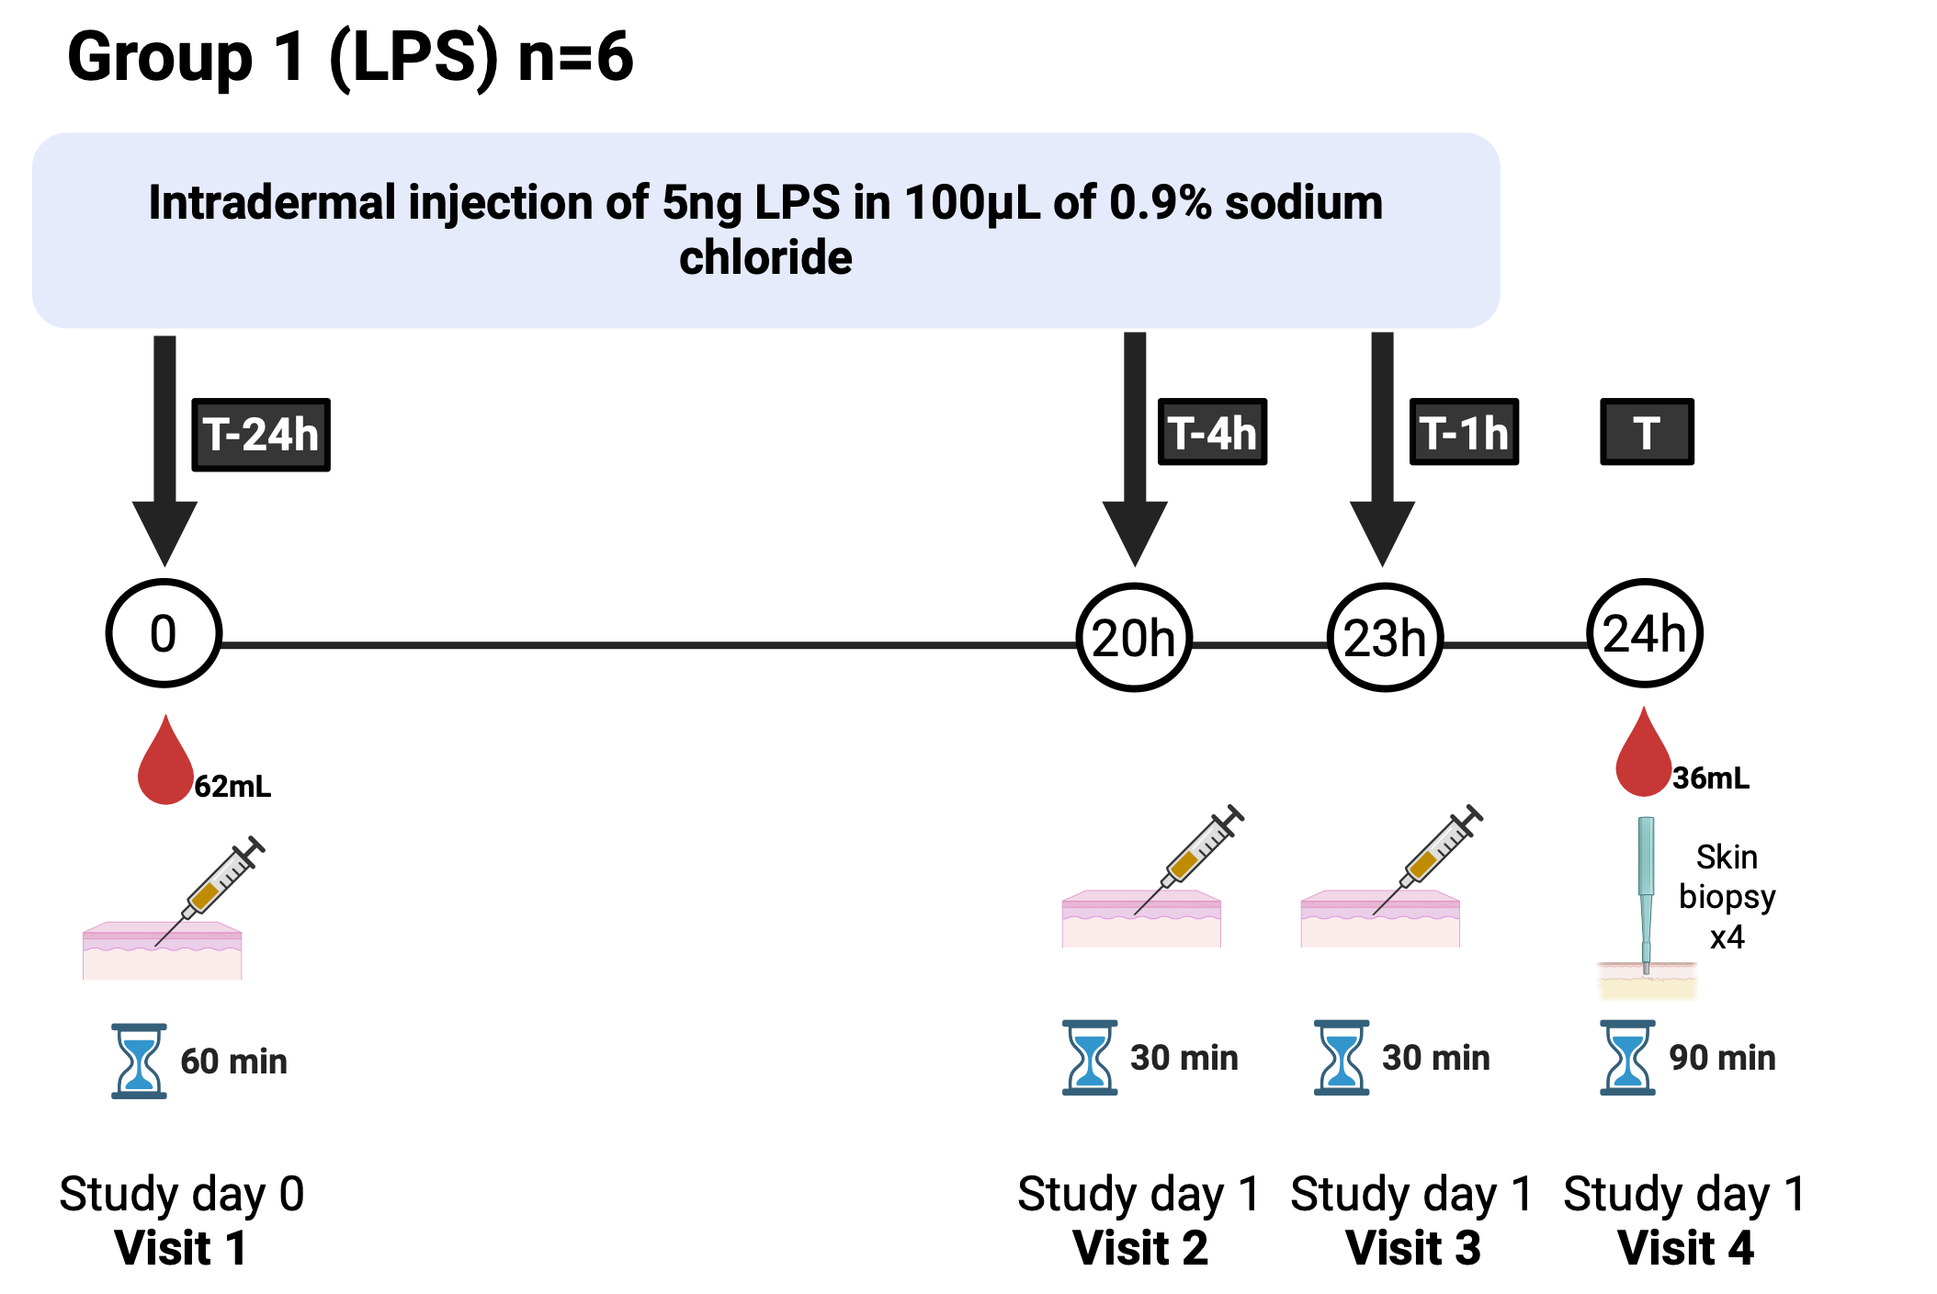

Figure *2* Group 1 visit schedule

**Study visits: Group 2-4**

Visit 2 and Visit 3: days 5 and 6

You will return to the research facility on the days specified above and as agreed. We will ask you questions about any adverse events and any other relevant medical history since your last visit. We will check your observations and, if you are a woman of childbearing potential, perform a urine pregnancy test. We will then inject LPS or BLM in the skin or apply cantharidin on the skin of the inner forearm a further 2 times (once per visit, in different places each time), depending on your Group allocation. We will mark challenge sites with ink. You may then leave the research facility.

Visit 4: day 7

You will return to the research facility again. We will ask you questions about any adverse events and any other relevant medical history since your last visit. We will check your observations. The skin response at each of the challenge sites will be assessed with methods described in Figure 1. If you are in Group 3 (cantharidin) we will ‘pop’ and collect the blister fluid that has collected along with the ‘roof’ of the blister. We will then perform punch skin biopsy at these sites and at an additional unchallenged site for comparison. We will also take a blood test at this point. You may then leave the research facility, and there will be no further visits.

The day of each visit, approximate duration, and biological samples taken on each occasion for each of Groups 2-4 are shown in Figures 3-5.

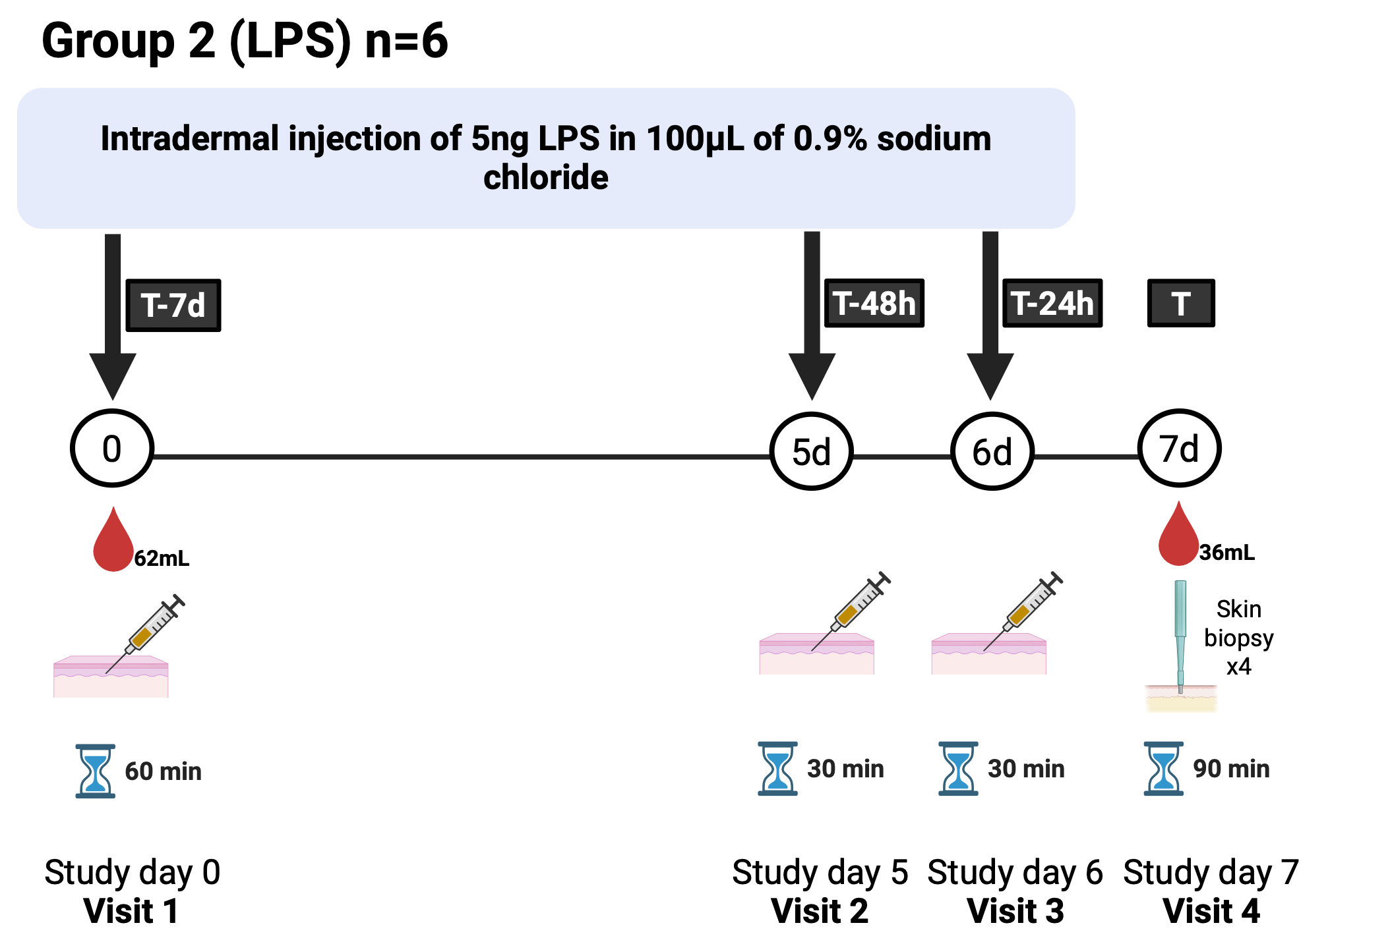

Figure 3 Group 2 visit schedule

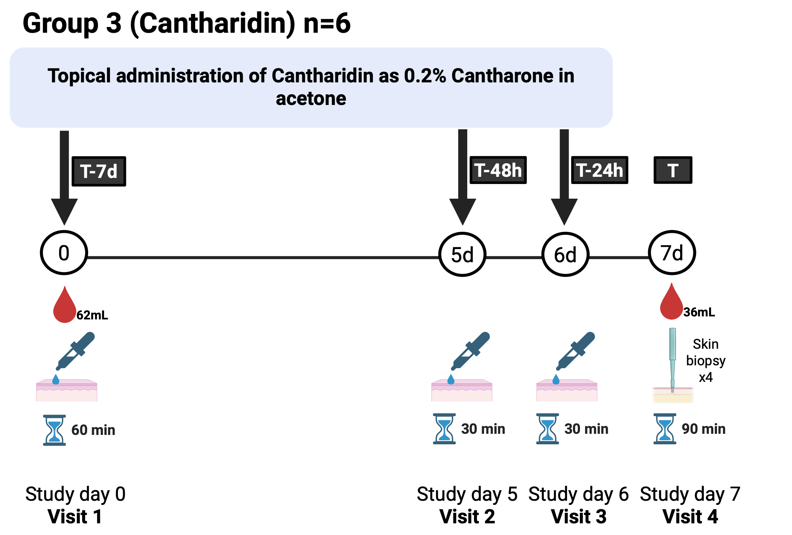

Figure 4 Group 3 visit schedule

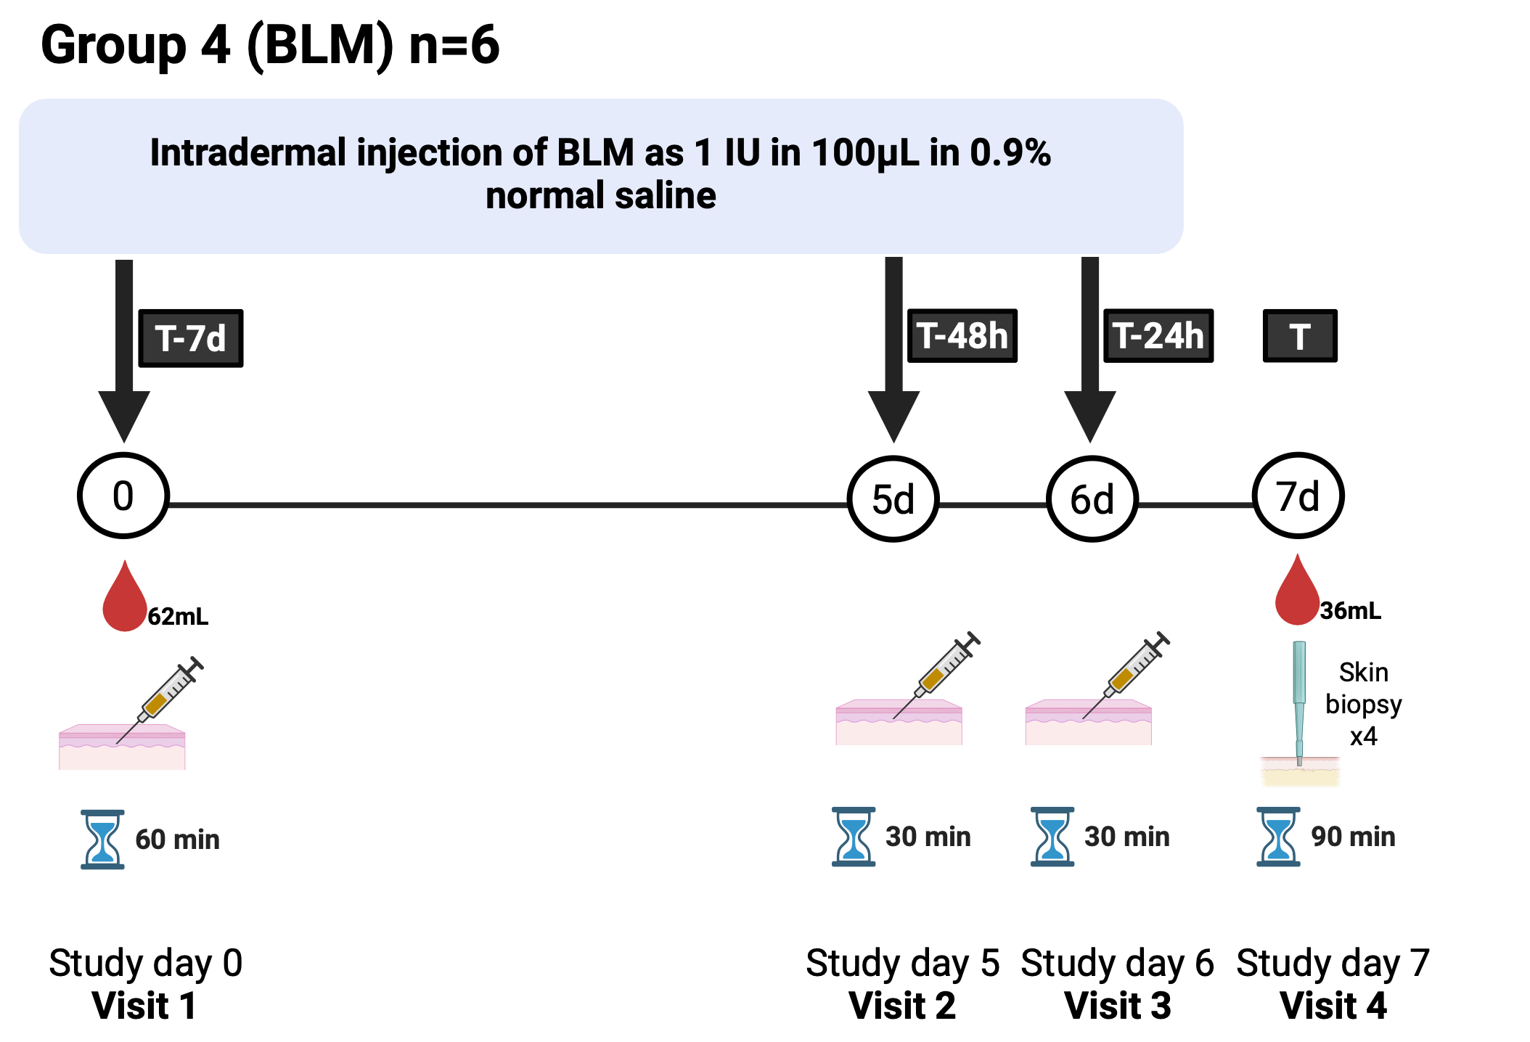

Figure 5 Group 4 visit schedule

## Study procedures

Clinical evaluation

At all visits we will ask questions to confirm you are still healthy and suitable for the study. Your blood pressure, heart rate, and temperature will be recorded. For women of childbearing potential, a urine pregnancy test will be performed.

Blood tests

We will take blood samples to measure the status of your immune system, as a baseline prior to the first application of the challenge agent (LPS, cantharidin, or BLM), and at the final visit prior to the skin biopsies. We will perform assessments to understand which parts of the immune system are turned on in responses to the challenge agents such as cells and genes. We will also do tests for evidence of previous infections with viruses which very commonly infect people as children or in early adulthood (cytomegalovirus), as these viruses may affect the immune response to the challenge agents or provide additional insight into the way your immune system reacts to infection/inflammation. We may also perform assessments of your DNA (the body’s ‘instruction manual’) to see if this can explain any differences in the immune response we observe. The total volume of blood taken on occasion will be approximately up to 62mL (about 3 tablespoons), and the total amount of blood taken over the course of the study will be approximately 98mL (about 2/3 of a cup, or 1/4 of a standard NHS blood donation)

Challenge sites

LPS, Cantharidin, or BLM will be applied on three occasions. The timing of these applications will vary according to study group and is shown in figures 2-5. The approximate sites of these applications is shown in Figure 6. These will be identified at Visit 1 and relate to both to local anatomy (e.g. large veins, any moles or marks) and your arm dominance (to minimize inconvenience).



Figure 6 : Approximate sites of LPS, cantharidin, or BLM challenge agent application.

Skin assessment:

*Clinical assessment:* We will assess the skin response to LPS, Cantharidin, and BLM by measuring the amount of redness and minor swelling which can be detected by a trained observer, using a ruler and the ‘ball-point pen’ technique (Figure 1A).

*Ultrasound*: We will use an ultrasound machine to look at the thickness of the skin at the site of LPS, Cantharidin, or BLM application (Figure 1D). We use gel to help improve the ultrasound pictures. The ultrasound procedure is painless and harmless, and should take less than 5 minutes to complete.

*Photography*: We will take close up images of the skin responses to track the changes in the skin (Figure 1C, E). The pictures will include just the site of challenge agent application and surrounding skin and will not contain any identifying information.

*Multispectral imaging*: We will use a special camera called a multispectral imaging camera to take a close-up picture of the skin response (Figure 1E). The multispectral imaging procedure is painless and harmless and it takes just a few seconds to take each picture. The pictures will include just the site of the challenge agent application and surrounding skin and will not contain any identifying information.

*Laser Doppler*: We will use a special instrument called a laser Doppler to measure the amount of blood flow in the skin (Figure 1A - right). The laser Doppler procedure is painless and harmless and requires you to sit still for 5-10minutes whilst the image is taken. Appropriate safety equipment (goggles) will be provided.

Punch skin biopsy:

We will take up to four samples of skin at the final visit, using a special device called a punch biopsy (Figure 7). The skin will be taken from areas where you were given the LPS, Cantharidin, or BLM and at an additional unchallenged site for comparison. In all cases the biopsies will be taken from inside/underside of the lower forearms (the hairless side). In those in Group 3, the blister formed following cantharidin exposure will be ‘popped’, the blister ‘roof’ removed and the fluid inside collected prior to biopsy.

To take the biopsy we will clean the skin with antiseptic and then give an injection of local anaesthetic to minimise discomfort. The punch biopsy takes a small circular piece of skin (4-6mm in diameter, about the size of 2-3 grains of rice side by side). We will then close the skin with special plasters (steristrips) or a single dissolvable stitch, if necessary. We will then put a dressing over these biopsy sites, which can be left on until it falls off, or removed carefully after 48h.

Figure 7 Punch skin biopsy procedure. From https://www.healthdirect.gov.au/surgery/punch-biopsy-of-a-skin-lesion

After the biopsy you will be asked to keep the area dry for 48h, then you can bathe/swim normally. If a stitch has been used this will dissolve and fall out on its own in about in about 10 days. or it can be removed by soaking and gently removing at 10 days.

Participant experience questionnaire

On your final visit will ask you to complete a paper-based questionnaire about your experience in the study to date, e.g. how you found the study procedures, and whether you would volunteer for similar studies in the future, based on your experience in this study.

End of the study

Following your final visit we will make sure that you have contact details for the study team in case there are any problems after this, such as any concern around the healing of the punch biopsy sites (this is very unlikely).

# What should I consider?

It is important to consider whether you can commit to coming for all study visits.

If you take part in the study we will ask you to adhere to the following restrictions on your activity:

* During the study
  + To avoid excessive sun exposure from the time of screening through to the final visit, including recreational sunbathing
* Within 12 hours of the start of each visit:
  + To abstain from ingesting (eating or drinking) tea, coffee, cola drinks and other caffeine containing substances, and chocolate.
* Within 24 hours of the start of each visit:
  + To abstain from ingesting any alcohol
  + To abstain from strenuous exercise. You may participate in light recreational activities during this time (e.g. mild intensity exercise for 30 minutes or less).
  + To abstain from consuming non-steroidal anti-inflammatory drugs and antihistamines
* Within 30 days of the study and while participating in the study:
  + To abstain from any nicotine containing products (including cigarettes and vapes).
  + To abstain from recreational sun-bathing.
  + To abstain from use of topical creams, ointments, or gels containing corticosteroids or non-steroidal anti-inflammatory drugs.
* Within 60 days of the study and while participating in the study
  + To abstain from use of sun-beds

Cantharidin (Group 3)

* If you are allocated to Group 3 (cantharidin) it is important that you take care of the blisters that will form at the site.
* We will a) provide you with a protective cap over the site and waterproof dressing and b) undertake the first and second applications on your non-dominant arm so that this provides as little inconvenience as possible. The cap will be removable to allow the site to ‘breathe’ and also so that the response can be monitored (see Figure 8 for example images).
* Fluid in blisters will be collected at Visit 4 (i.e. 1, 2 and 7 days after the cantharidin was first applied). The blister ‘roof’ will also be collected.
* *Do:*
  + Wear loose fitting clothing to protect the blister and dressing
  + Stick down any part of the dressing that starts to peel off or let us know so it can be changed
* *Do not:*
  + Apply cream or ointment to your arms prior to study visits
  + Get the dressing wet if possible. Cool gentle showers or baths are permitted provided the arm is kept dry (cling film may be used in the shower) but we advise avoiding bathing/showering for at least 24hrs after application
  + Participate in sports or any heavy physical work while the dressing is in place, as sweating may cause the dressing to fall off.

Skin biopsies

* Following the skin biopsies you will need to take care to not disturb the skin too much until the skin is healed.

Women of childbearing potential

For female participants, we consider you to be of childbearing potential unless you have had previous surgical sterilisation (e.g. hysterectomy, bilateral salpingectomy, bilateral oophorectomy). Female participants of childbearing potential are required to use an effective form of contraception from the day of first administration of LPS, cantharidin, or BLM until 6 months (180 days) days after the last administration. Acceptable forms of contraception for participants of childbearing potential include:

* Established use of oral, injected or implanted hormonal methods of contraception
* Placement of an intrauterine device (IUD) or intrauterine system (IUS)
* Male sterilisation, if the vasectomised partner is the sole partner for the subject.
* True abstinence (defined as refraining from heterosexual intercourse) when this is in line with the preferred and usual lifestyle of the subject.

Note that following methods ARE NOT considered acceptable method of contraception

* Barrier methods of contraception (condom or occlusive cap with spermicide).
* Periodic abstinence and withdrawal.

We ask that participants contact the study team (with the contact details provided above), if they become pregnant (or suspect they are pregnant) within 180 days of exposure to the challenge agents. In this event, with your consent, we will request that you have a pregnancy test within 7 days. If pregnancy is confirmed, the study team will advise on the need for any additional investigation or follow-up related to the potential exposure of the pregnancy to the challenge agents, and provide information regarding your participation in the study to the obstetric team at the hospital you register (book) with. We will also seek your consent to collect additional information about the outcome of the pregnancy. The occurrence of pregnancy and the pregnancy outcome will be reported anonymously (de-identified) to the study funder (AbbVie).

**Information collected in the event of pregnancy of the participant**

If you become pregnant within 180 days of exposure to the challenge agents, we will request additional information from you, related to your pregnancy. This may be throughout your pregnancy, once your baby is born and for some time (up to 12 weeks) after the birth. The type of information requested may include the following:

* How and when the pregnancy was confirmed and conceived
* Expected delivery date
* Your medical history (if relevant to your health during pregnancy/your baby’s health)
* A history of previous pregnancies
* Any medications you may have taken since you became pregnant
* Any procedures you have received (for example X-rays or surgery) since becoming pregnant
* Information on the progress and outcome of the pregnancy, including the diagnosis of any congenital abnormality or birth defect.

To collect this information, members of the study team will contact you around the following time-points:

* Week 12 of pregnancy
* 12 weeks after delivery

# Are there any possible disadvantages or risks from taking part?

The disadvantages of taking part relate to the inconvenience of attending for study visits, and the small risk of adverse effects of the study procedures. You should consider the following risks before agreeing to take part:

## Potential risks of the challenge agents

Expected common adverse effects are limited to mild responses at the application site e.g. stinging pain, redness, warmth, swelling, tenderness or itching. In very rare cases, more severe local skin reactions could occur. Anaphylactic or anaphylactoid reaction have also been rarely reported. If either of these were to occur we would not give any further challenge agent (LPS, cantharidin, BLM) and would withdraw you from the study, while also providing any appropriate medical care that you might need, or referring you to your GP or other NHS service as required.

High-dose BLM use as part of chemotherapy for cancer is associated with multiple side effects and risks. These are not seen when administered locally for the treatment of warts, vascular lesions, or cancers in the skin. Risk rises with age (>40 but notably >70 years) and dose. In taking part in this study you would receive a dose around 100,000x lower than that used in chemotherapy and circa 300x less than used clinically per skin injection site (greater than 1000x less than over a complete normal skin-injected treatment course).

|  |  |
| --- | --- |
| ***Frequency*** | ***Side effect*** |
| *Very common (in more than 1 in 10 participants)* | Local inflammatory reaction (redness, warmth, swelling) expected in all participants.  Mild pain at the injection site  Painless blistering (cantharidin only - expected to occur in all participants in Group 3)  Hyperpigmentation or hypopigmentation at the injection/biopsy site |
| *Common (more than 1 in 100 but fewer than 1 in 10)* | Moderate pain, itching or burning sensation  Transient lymphadenopathy (local gland swelling) |
| *Rare (fewer than1 in 1000)* | Severe pain, itching or burning sensation, blistering, swelling.  Skin ulceration. |

## Potential risks of tests performed as part of the study

To minimize the risk of problems, all study procedures will be performed by experienced professionals using appropriate precautions and equipment.

Blood donation

If you take part in the study and complete all follow-up the total amount of blood taken will be about 2/3 of a cup or ¼ of an NHS blood donation (98mL). As such it would not be expected to cause problems for an otherwise healthy volunteer. The blood donation itself requires the use of a needle into a vein of the arm, and this can cause minor bruising, tenderness, and occasionally feeling faint or actually fainting. Very rarely sites of blood tests can become infected and require antibiotic treatment. The blood tests will be taken by experienced members of the study team which should minimize the risks of side effects.

Skin punch biopsy

Skin punch biopsy is a commonly performed medical procedure. The potential risks include minor bruising, bleeding, and skin discomfort. A 4-6mm punch biopsy (equivalent to 2-3 grains of rice laid side-by-side) will be performed using local anaesthetic to reduce discomfort. The injection of anaesthetic can cause stinging during injection which fades very quickly as the anaesthetic takes effect. It is normal for a small scar or persistent skin discoloration to be visible once the skin has healed—this usually fades over time but may be permanent. In rare cases, certain individuals can develop more prominent scars (called keloids). We will exclude people from the study who are known to have developed keloids previously, or have a family history of this, because we know this increases the risk of keloids. There is a very small risk of infection following skin biopsy—this is minimized by use of skin antiseptic at the time of biopsy, and careful technique of the doctor performing the biopsy.

# What are the possible benefits of taking part?

By participating in this study, you will not directly receive any personal health benefit.

However, you will help us develop better tools to understand the immune system, thereby potentially benefiting other people with diseases caused by, or causing, malfunction of the immune system, e.g. eczema / atopic dermatitis.

# Will my General Practitioner (GP) be informed of my participation?

We will not routinely send a letter to your GP informing them of your participation in the study. If we incidentally find an issue during the study that may be important for your health (e.g. high blood pressure, blood test abnormalities), we will inform your GP, or ask you to contact them, to ensure appropriate follow-up can be arranged.

# Will my taking part in the study be kept confidential?

All information that is collected about you during the course of the study will be kept strictly confidential. It is available only to the study team. Responsible members of the University of Oxford and regulatory authorities may be given access to data for monitoring and/or audit of the study to ensure that the research is complying with applicable regulations.

To help keep your information confidential, your sample and any information recorded about you in this study will be protected by assigning you a study code, which will be used on all study documents and any electronic database(s). All documents will be stored securely and only accessible by study staff and authorised personnel. We will only use your NHS number where this is necessary to link to your NHS records. The study staff will safeguard the privacy of participants’ personal data.

# Will I be reimbursed for taking part?

You will be compensated for your travel costs, time and inconvenience related to taking part in this study. The total amount of compensation you receive will depend on your degree of involvement:

* £30 if you attend the screening visit, but do not enter the main study (either due to your choice or decision of the study team).
* £100 if you attend the screening visit, and take part in the visit 1 study procedures, but do not complete all study procedures and follow-up (e.g. If you withdraw from the study, either due to your choice or the decision of the study team).
* £600 for completing the screening and all study procedures and follow-up.

To claim this reimbursement, at the completion of your involvement in the study we will send you an electronic claim form via email – once you complete this we will submit the information to the University finance team and the payment will be made directly into your bank account.

Note that the study payment includes compensation for travel expenses. We will not provide further reimbursement for travel expenses in addition this payment.

We will not pay tax or National Insurance from the money due to you. It is your responsibility to pay these and to check how any compensation received from taking part in the study affects any state benefits to which you are entitled. Contact HM Revenue & Customs for information (http://www.hmrc.gov.uk/ or telephone 0300 200 3300).

# What will happen to the samples I give?

If you agree to take part in this study, the samples you give will be used for the scientific purposes described above. You will also have the option to permit use of your samples in future research. Samples will be stored locally by the Translational Pharmacology group.

Your samples will be used in a form that does not identify you, mainly by researchers based at NDORMS, University of Oxford but analyses for this study may take place in hospitals, universities, non-profit institutions, or commercial laboratories worldwide*.* Because they will be shared in a form that does not link back to you, it will not be possible to withdraw them after they are shared.

We will ask for your consent for the use of your samples to be stored indefinitely, and used in future ethically approved studies. If you agree to this, your anonymised samples will be used mainly by local researchers (if applicable), but ethically approved research projects may take place in hospitals, universities, non-profit institutions or commercial laboratories worldwide. If you do not agree to this, then any samples remaining at the end of this study will be destroyed—we will do this within 18 months of completion of the study.

To help keep your information confidential, your sample and any information recorded about you in this study will be assigned a study code that is used instead of your name or other identifiers. However, your DNA is unique to you so it can never be completely anonymous*.*

# What will happen to my data?

Data protection legislation requires that we, the University of Oxford (whose legal name is The Chancellor Masters and Scholars of the University of Oxford), state the legal basis for processing information about you. In the case of research, this is a ‘task in the public interest’. The University of Oxford is the sponsor for this study and is responsible for looking after your information and using it properly.

We will need to use information from you for this research project. We will share your information related to this research project with the following types of organisations: the local NHS Trust, a national volunteering database (see below) and, only where necessary for context (e.g. age and sex), research partners (both academic and commercial organisations).

This information will include your NHS number, name, contact details and some demographic data (e.g. age and sex). People will use this information to do the research or to check your records to make sure that the research is being done properly. People who do not need to know who you are will not be able to see your name or contact details. Your data will have a code number instead.

We will keep all information about you safe and secure by:

* limiting access to data to only those people who need it for the research
* using the minimum personally-identifiable information possible
* storing it as securely as possible, for instance in locked cabinets on University premises for written documents, or on password-protected University-controlled computers for electronic information

***International Transfers***

We may share data about you outside the UK for research related purposes to:

* Permit additional analysis
* Contextualise data arising from the study
* Gain the insight of academic partners

If this happens, we will only share the data that is needed. We will also make sure you can’t be identified from the data that is shared where possible. This may not be possible under certain circumstances – for instance, if you have a rare illness, it may still be possible to identify you. If your data is shared outside the UK, it will be with the following sorts of organisations:

* Higher education institutions (i.e. Universities)
* Commercial organisations

We will make sure your data is protected. Anyone who accesses your data outside the UK must do what we tell them so that your data has a similar level of protection as it does under UK law. We will make sure your data is safe outside the UK by doing the following:

* (some of) the countries your data will be shared with have an adequacy decision in place. This means that we know their laws offer a similar level of protection to data protection laws in the UK
* we use specific contracts approved for use in the UK which give personal data the same level of protection it has in the UK. For further details [visit the Information Commissioner’s Office (ICO) website](https://ico.org.uk/for-organisations/uk-gdpr-guidance-and-resources/international-transfers/)
* we do not allow those who access your data outside the UK to use it for anything other than what our written contract with them says
* we need other organisations to have appropriate security measures to protect your data which are consistent with the data security and confidentiality obligations we have. This includes having appropriate measures to protect your data against accidental loss and unauthorised access, use, changes or sharing
* we have procedures in place to deal with any suspected personal data breach.  We will tell you and applicable regulators when there has been a breach of your personal data when we legally have to. For further details about UK breach reporting rules [visit the Information Commissioner's Office (ICO) website](https://ico.org.uk/for-organisations/report-a-breach).

Once we have finished the study, we will keep some of the data so we can check the results. We will write our reports in a way that no-one can work out that you took part in the study.

We will keep your study data for the minimum period of time required by the University Policy on Management of Data. This includes:

* Your contact details for 12 months after the study has finished.
* Your consent form will be stored for 3 years after the study has finished, unless you agree to for your samples to be used in future research or for us to contact you about future research (see below).
* Your bank details will be stored for 7 years in accordance with University of Oxford financial policy.

What are your choices about how your information is used?

You can stop being part of the study at any time, without giving a reason, but we will keep information about you that we already have. You have the right to ask us to remove, change or delete data we hold about you for the purposes of the study. We might not always be able to do this if it means we cannot use your data to do the research. If so, we will tell you why we cannot do this.

If you agree to take part in this study, you will have the option to take part in future research using your data saved from this study. This will be stored locally by the Translational Pharmacology group.

Your consent form will be held securely until the samples have been used up. If you agree to your details being held to be contacted regarding future research, we will retain a copy of your consent form securely until such time as you request removal from our database. We will keep the consent form and your details separate from one another and any research data.

We may use third party service providers or subcontractors to help with some of the research activities we carry out (e.g. IT provision, specific biological sample analysis). We may therefore share your personal data with these providers when it is necessary to do so to allow them to carry out the services we require them to provide. However, we require all our third-party providers to have appropriate security measures in place to protect your data and we only allow them to process your data for the specific purposes we have stated in our instructions.

You can find out more about how we use your information, including the specific mechanism used by us when transferring your personal data out of the UK, by:

* asking one of the research team: [james.fullerton@ndorms.ox.ac.uk](mailto:james.fullerton@ndorms.ox.ac.uk)
* sending an email to [translationalpharmacology@ndorms.ox.ac.uk](mailto:translationalpharmacology@ndorms.ox.ac.uk)
* calling us on 01865 613728
* contacting the University’s Data Protection Officer [data.protection@admin.ox.ac.uk](mailto:)
* looking at the University’s privacy notice available at: [How we use your personal data for research purposes | Compliance](https://compliance.admin.ox.ac.uk/research-data).

If you would like to find out more about the use of confidential data in research, the HRA has developed a general information leaflet which is available at: [Patient data and research leaflet - Health Research Authority](https://www.hra.nhs.uk/planning-and-improving-research/policies-standards-legislation/data-protection-and-information-governance/gdpr-guidance/templates/template-wording-for-generic-information-document/).

# Additional data storage: TOPS database

Healthy volunteers must not take part too often in trials of new medicines and other scientific studies (such as this one), for scientific, medical and ethical reasons (i) if the gap between two studies is too short, or the studies overlap, the medicines might interact, (ii) taking too many blood samples could cause anaemia, (iii) it’s unethical to expose healthy people too often to medicines they don’t need

So, to help research units, the Health Research Authority keep a database of healthy volunteers and when they take part in studies--this is called TOPS. We will enter into the database your National Insurance number (if you’re a UK citizen), or your passport number and country of origin (if you’re not a UK citizen) and the date of your last dose of study medicine. If you withdraw from the study before you receive any study medicine, the database will show that you never received a dose.

With regards to data stored in the TOPS database, only staff at the NIHR Oxford Clinical Research Facility and other medicines research units can use the database. We may call other units, or they may call us, to check your details. Data entered in TOPS is retained for the minimum period required and this is determined based on whether you receive a dose of the study medicine or not. If you receive a dose of the study medicine, this data will be retained indefinitely in TOPS. If you do not receive a dose, your data will be retained in TOPS for two years*.* If we need to contact you about the study after you’ve finished it, but we can’t because you’ve moved or lost contact with your GP, we might be able to trace you through the information in the database

# What will happen if I don't want to carry on with the study?

Participation is entirely voluntary. If you change your mind you can withdraw at any time without giving a reason, without penalty, and without affecting your legal rights. If you withdraw from the study, any samples and data collected before your withdrawal will be used for research as detailed in this participant information sheet, unless you specifically request otherwise. However, if any of your anonymised data has been incorporated into the study or uploaded to open access research repositories, it will not be withdrawn or erased in order to maintain the scientific integrity of the study. Any data entered into TOPS will be retained if you withdraw from the study.

# What will happen to the results of this study?

The results of this project will be disseminated via standard scientific channels: publication in scientific journals, poster and oral presentations at scientific conferences. Anonymised data may be uploaded to open access research repositories. The data will contribute to the fulfilment of doctoral research project and presented in the thesis. You will not be able to be identified in any of these. When you enter the study we will ask if you would like to be informed of the results when they become available, and how you would like to receive them (e.g. email, post, and/or link to a website).

# What if we find something unexpected?

If we incidentally find an issue during the screening or during study that may be important (e.g. high blood pressure, blood test abnormalities) we will inform you of this. Depending on the results, you may not be eligible for the study, and you may be advised to contact your GP for further tests or review. We will also provide copies of these results to your GP. In some cases, the study doctor may simply recommend that the blood tests be rechecked on a later date, before deciding on eligibility. You will be compensated for this additional blood test on a pro-rata basis.

# What if there is a problem?

If you wish to complain about any aspect of the way in which you have been approached or treated, or how your information is handled during the course of this study, you should contact the Chief Investigator, Dr James Fullerton (contact details at the top of this form) or you may contact the University of Oxford Research Governance, Ethics & Assurance (RGEA) office on 01865 616480, or the director of RGEA, email [rgea.complaints@admin.ox.ac.uk](mailto:ctrg@admin.ox.ac.uk).

The investigators recognise the important contribution that volunteers make to medical research, and will make every effort to ensure your safety and wellbeing. The University of Oxford, as the research sponsor, has appropriate insurance in place in the unlikely event that you suffer any harm as a direct consequence of your taking part in this study. If something does go wrong, you are harmed during the research, and this is due to someone's negligence, then you may have grounds for a legal action for compensation. While the Sponsor will cooperate with any claim, you may wish to seek independent legal advice to ensure that you are properly represented in pursuing any complaint. The study doctor can advise you of further clinical action and refer you to a doctor within the NHS for treatment, if necessary.

# How have patients and the public been involved in this study?

Our research group works closely with our patient engagement network (‘OPEN ARMS’) to ensure that our research can truly benefit people living with inflammatory and immune system conditions. We will work with OPEN ARMS to communicate the results of this study (e.g. via newsletters and public ‘meet the researcher’ events) with the aim of highlighting how research involving healthy volunteers can contribute to our understanding of different immune system diseases and the development of new treatments. More information about OPEN ARMS can be found at <https://www.ndorms.ox.ac.uk/get-involved/open-arms-1/open-arms>

# Who is organising and funding the study?

* This study is sponsored by the University of Oxford.
* It is being funded by AbbVie.
* All researchers involved in this study are employees of the University of Oxford. No members of the study team will receive additional payments for enrolling you in this study.

# Who has reviewed the study?

All research in the NHS is looked at by an independent group of people, called a Research Ethics Committee, to protect participants’ interests. This study has been reviewed and given a favourable opinion by Riverside Research Ethics Committee.

# Participation in future research:

We will ask you if you are willing to be approached to be involved in future studies. Your contact details will be held separately on password protected computer servers maintained by NDORMS, University of Oxford. Agreeing to be contacted does not oblige you to take part in future research, and you can be removed from this register at any time you wish.

# Further information and contact details:

[Please](mailto:Please) contact us at [translationalpharmacology@ndorms.ox.ac.uk](mailto:translationalpharmacology@ndorms.ox.ac.uk) if you would like further information or to ask any questions. Alternative you can contact directly Dr James Fullerton (Chief Investigator and Clinical Pharmacologist, james.fullerton@ndorms.ox.ac.uk) or Dr Philip Drennan (Co-Investigator, Clinical Pharmacologist, and Clinical Research Fellow, NDORMS, philip.drennan@ndorms.ox.ac.uk).

**Thank you for reading this information sheet and for considering taking part in this research study.**